**EBARANGAY: AN APPLICATION MANAGEMENT**

**SYSTEM WITH PUROK INTEGRATION AND**

**FLOW OF WORKLOAD**

A Capstone Project Presented to the Faculty of College of

Computer, Information and Communication Technology Department

Cebu Technological University - Main Campus

In Partial Fulfillment of the Requirements

for the degree Bachelor of Science in Information Technology

By

Craige Jonard N. Baring

Sajid O. Cadavero

Rosvie R. Pepito

Ball S. Campanilla, Ph. D

Adviser

December 2021

**ACKNOWLEDGEMENT**

The Team RJS would like to extend our deepest appreciation to the people who helped and contributed to the success in this study.

First of all, we would like to thank the Almighty God for giving us courage and strength while working with this study. This study would not be done without his guidance.

We also extend our deepest gratitude to those who support this work especially our parents, supporting us emotionally and financially, trusting and believing us all throughout the way. We also thank our close friends, and classmates, who gave advice, and opinions for the improvements of this study.

To our adviser, Mr. Bell Campanilla, for giving us assistance and support with the research. The researchers, acknowledge the encouragements and suggestions from our adviser to help the reasearcher for better results.

To our professor, Mr. Bell Campanilla, for guiding us with our research, and to give out necessary feedback for us to grow better.

To us, the researchers, Rosvie R. Pepito, Sajid Cadavero, and Craige Jonard N. Baring for working together as a team in creating this study.

**DEDICATION**

This study is dedicated to the people who believed in our skills and determination. To our loving parents for their undying support, guidance, and understanding along the way. Also. The people workmates, and friends who helped us in their in their own little ways in this study. To the faculty members who shared their knowledge and experience to the RJS team. To our supportive adviser who has supported and guided us along the way. And especially to our Creator, the Almighty God for giving us the continuous strength, and faith to conduct the study.

**TABLE OF CONTENTS**

TITLE PAGEi

ACKNOWLEDGEMENTii

DEDICATIONii

TABLE OF CONTENTSiv

LIST OF TABLESvii

LIST OF FIGURESviii

**CHAPTER I – INTRODUCTION1**

Rationale of the Study1

Objectives of the Study3

Significance of the Study5

Flow of the Study6

Definition of Terms7

**CHAPTER II – REVIEW OF RELATED LITERATIRE AND STUDIES8**

Related Literature8

Related Studies10

**CHAPTER III – RESEARCH METHODOLOGY13**

Scope and Limitation13

Software Engineering Methodology14

Planning Phase16

Business Model Canvas16

Program Workflow17

Gantt Chart32

Functional Decomposition Diagram35

Analysis Phase37

Use-Case Diagram37

Storyboard47

Database Design5

Entity-Relationship Diagram55

Data Dictionary57

Network Design64

Network Model64

Network Topology65

Development Phase66

Technology Stack Diagram66

Software Specification67

Hardware Specification67

Program Specification68

List of Modules68

Testing Phase75

Unit Testing75

Integration Testing75

Implementation/Development Phase76

Software Specification76

Hardware Specification76

User-Guide77

Installation Guide84

CONCLUSION86

RECOMMENDATION87

REFERENCES89

APPENDICES90

Appendix A. Capstone 2 Oath of Confirmation90

Appendix B. Research Working Title Form93

Appendix C. Capstone 2 Consultation Logs Form94

CURRICULUM VITAE96

**LIST OF TABLES**

Table 1: Comparative Matrix12

Table 2: Capstone 1 Gantt Chart: Projected32

Table 3: Capstone 1 Gantt Chart: Completed 33

Table 4: Capstone 2 Gantt Chart: Projected 33

Table 5: Capstone 2 Gantt Chart: Completed 34

Table 6: Data Dictionary58

Table 7: Manage Account Module - Web 68

Table 8: Request Document Module - Web 68

Table 9: Ebulletin Module - Web 69

Table 10: Manage Complaints Module - Web 70

Table 11: Manage Residents Module - Web 71

Table 12: Manage Notification/Messages Module - Web 71

Table 13: Voting Module - Web72

Table 14: Manage Account Module - Mobile72

Table 15: Request Document Module - Mobile 73

Table 16: Ebulletin Module - Mobile 73

Table 17: Manage Complaints Module - Mobile 74

**LIST OF FIGURES**

Figure 1: Flow of the Study6

Figure 2: BeST Barangay System10

Figure 3: e-Barangay visual of their Functionality11

Figure 4: Iterative Model - Design14

Figure 5: Business Model Canvas16

Figure 6: Resident – Web Workflow17

Figure 7.1: Purok Leader - Web Workflow18

Figure 7.2: Purok Leader - Web Workflow19

Figure 8.1: Treasurer - Web Workflow20

Figure 8.2: Treasurer - Web Workflow21

Figure 9.1: Secretary - Web Workflow22

Figure 9.2: Secretary - Web Workflow23

Figure 10.1: Captain - Web Workflow24

Figure 10.2: Captain - Web Workflow25

Figure 11: Admin – Web Workflow26

Figure 12: Resident – Mobile Workflow27

Figure 13: Purok Leader – Mobile Workflow28

Figure 14: Treasurer – Mobile Workflow29

Figure 15: Secretary – Mobile Workflow30

Figure 16: Captain – Mobile Workflow31

Figure 17: Web - Functional Decomposition Diagram35

Figure 18: Mobile – Functional Decomposition Diagram36

Figure 19: Resident – Use-Case Web37

Figure 20: Purok Leader – Use-Case Web 38

Figure 21: Treasurer – Use-Case Web 39

Figure 22: Secretary – Use-Case Web 40

Figure 23: Captain – Use-Case Web 41

Figure 24: Admin – Use-Case Web 42

Figure 25: Resident Verification – Use-Case Web 43

Figure 26: Captain – Use-Case Mobile44

Figure 27: Secretary – Use-Case Mobile 44

Figure 28: Treasurer – Use-Case Mobile 45

Figure 29: Purok Leader – Use-Case Mobile 45

Figure 30: Resident – Use-Case Mobile 46

Figure 31: Storyboard – Register Page46

Figure 32: Storyboard – Login Page46

Figure 33: Storyboard – Admin Page47

Figure 34: Storyboard – Profile Page47

Figure 35: Storyboard – eBulletin Page48

Figure 36: Storyboard – Dashboard Page48

Figure 37: Storyboard – Request Page49

Figure 38: Storyboard – eReklamo Page50

Figure 39: Storyboard – Residents Page50

Figure 40: Storyboard – Election Page51

Figure 41: Storyboard – Officers Page51

Figure 42: Storyboard – Report Page52

Figure 43: Storyboard – Login Page Mobile52

Figure 44: Storyboard – eBulletin Page Mobile52

Figure 45: Storyboard – Drawer Menu Page Mobile53

Figure 46: Storyboard – Request Page Mobile53

Figure 47: Storyboard – eReklamo Page Mobile53

Figure 48: Storyboard – Resident Page Mobile53

Figure 49: Storyboard – Profile Page Mobile54

Figure 50: Entity- Relationship Diagram56

Figure 51: Network Model64

Figure 52: Network Topology65

Figure 53: Technology Stack Diagram66

Figure 54: Login – User Guide77

Figure 55: Admin Page – User Guide77

Figure 56: Buttons – User Guide77

Figure 57: Add Barangay – User Guide78

Figure 58: Add Account – User Guide78

Figure 59: Captain Page – User Guide79

Figure 60: Add Candidate – User Guide79

Figure 61: Login Page – User Guide80

Figure 62: eBulletin – User Guide80

Figure 63: Navigation – User Guide81

Figure 64: Request – User Guide81

Figure 65: Complaint – User Guide82

Figure 66: Residents – User Guide82

Figure 67: Profile – User Guide83

**CHAPTER I – INTRODUCTION**

**Rationale of the Study**

The barangay is one of the smallest administrative government division in the Philippines. It is the foundation for a growing community. This serves as the primary planning and implementing unit of government policies, plans, programs, projects, and activities in the community, and as a forum wherein the collective views of the people may be expressed, crystallized, and considered, and where disputes may be amicably settled.

The practice of implementing a barangay is not only seen here in the Philippines but can also be observed in other countries, they call them towns. They are designed and authorized to perform certain governmental functions on the local level, and its main purpose is to exercise the power of the state to promote greater prosperity, safety, convenience, health, and the common good of the general community.

A barangay captain is an elected position by the residents in an area and supported by the government. Purok area is composed of fifty to 100 households. Purok leader is a chosen volunteer by the residents and therefore accepted and respected. A purok leader can be the bridge of information between the barangay captain and residents. (Matthies, 2017).

The eBarangay application will be proposed and distributed to the municipality of Mandaue City, Cebu utilizing the proposed revenue stream by the researchers to help manage the barangay that are under the municipality. The eBarangay application aims to divide the workload of the barangay with purok integration to achieve successful flow of workload. The management system of eBarangay helps to downgrade the services of the barangay which will receive, sort and send the complaints and concerns to the appropriate people for the concern such as the purok leader towards the barangay captain depending on the level of concern. Legal information is a very important news to every individual, with the eBarangay application. The barangay captain can post announcements. The purok leader can settle things of their responsibilities towards the residents towards the barangay captain, and residents will be able to send their requests and complaints, such as road integrity, electricity, water, noticing new faces, tracing and other upcoming concerns. The residents could also request for barangay documents remotely. The eBarangay application includes voting system by the residents to vote of such position.

**Objectives of the Study**

The main objective of this study is to design and develop a system that will bring the services of a barangay into electronic form with purok integration and flow of workload.

1. To develop an application that will enable residents to:
   * manage own account
   * view to eBulletin
   * send their complaints
   * request for barangay documents
   * vote for nominees
2. To develop an application that will enable the purok leader to:
   * manage own account
   * access to eBulletin
   * verify new user accounts
   * view list of resident’s profiles within their *purok* area
   * receive the concerns and complaints and requests
   * assess and perform necessary minor actions
   * send report
   * vote for nominees
3. Develop an application that will enable the barangay treasurer to:
   * manage own account
   * access to eBulletin
   * confirm payments
   * send reports
   * vote for nominees
4. Develop an application that will enable the barangay secretary to:
   * manage own account
   * access to eBulletin
   * view resident’s profiles within the barangay area
   * receive major concerns and complaints, the concerns and complaints from the resident users
   * send reports
   * vote for nominees
5. Develop an application that will enable the barangay captain to:

* manage own account
* access to eBulletin
* manage resident’s profiles within the *purok area*
* manage reports
* promote, demote or nominate user

1. Develop an application that will enable the admin to:
   * add officer account
   * view officer account
   * add resident
   * assign position
   * activate or deactivate barangay name
   * activate or deactivate purok name

**Significance of the Study**

**Residents.** The study will help strengthen the connection and gap of communication between thebarangay staff and its residents. It aims to give residents a platform to voice out what’s on their mind, and to access the services remotely for better convenience.

**Purok Leader:** The system will help the purok leader outline their duty within the purok they’reassigned to, and will aid with managing the information that’s being given to them. This system can help purok leaders to receive requests and complaints about the purok area and easily communicate to the captain. This aims to conveniently track the residents within the purok area.

**Barangay members**: The system will help the barangay members be able to immediatelydetermine who is in need with the services a barangay can give, concisely. The barangay member can be aware of the complaints of the residents and confirm status through the eBaranagay system.

The system will help the barangay member for the reduction of workload and easy to announce news with bigger scope of audience that all residents can easily be informed, conveniently track the status and details of every *purok* and immediately determine and access the needs of the residents.

**Flow of the Study**



Rationale of the Study

Objective of the Study

Related Literature

Related Studies

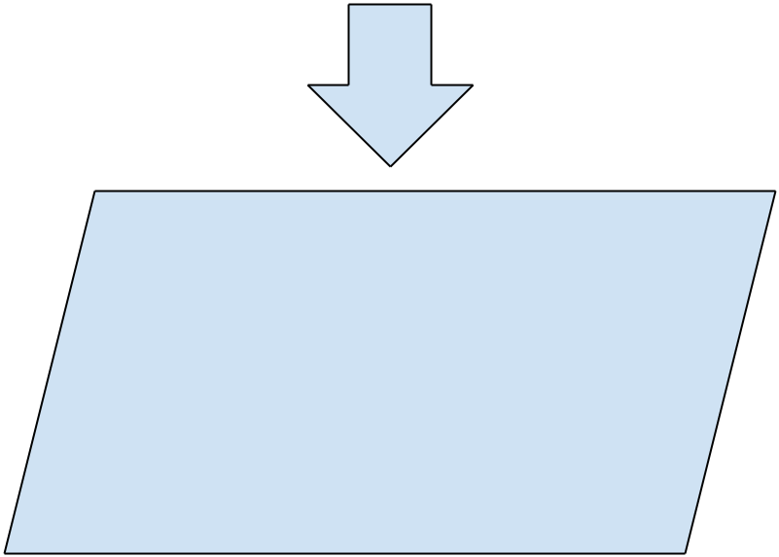

Customer Validation

Database Management Concept

Software Engineering Concept

Web Development Concept

Android Development Concept

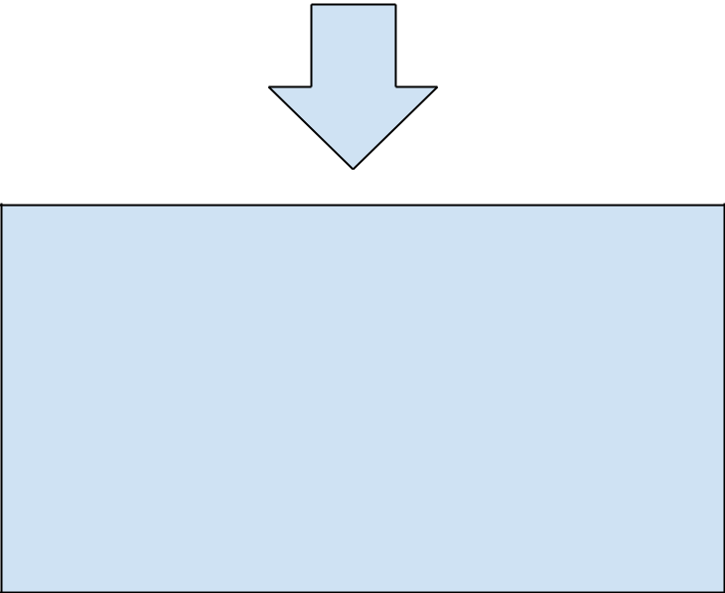

eBarangay: Application management system

with Purok integration and flow of workload

Figure 1: **Flow of the Study**

**Definition of Terms**

Barangay – Refers to a small administrative division of the Philippines that is lead by a team composed of a Barangay captain, Secretary, Treasurers, Auditors and Councilors

Purok – It is a division within a barangay; it often serves as a unit for delivering services and administration within a barangay

**CHAPTER II – REVIEW OF RELATED LITERATURE AND STUDIES**

**Related Literature**

Part of purok’s function is to receive, disseminate and act on information including the petty fights from the residents before passing over to the barangay captain. The United States hailed the purok system as the best practice of harnessing as the couriers of information to residents to implement strategies for disaster risk reduction (Curato & Calamba, 2018).

According to Cheng (2019), the formative years in establishing the purok system with an emphasis of volunteerism and self-help provided the necessary learning process for residents and municipal officials to overcome the challenge of coordination within the community and to the different levels of government.

Through systematic qualitative analysis, it is found that residents of a fishing village in San Francisco, Camotes could contextualize warning information to spur actions. The residents also evacuated without waiting for the Typhoon Haiyan to worsen, as well as the tourist (Ponce de Leon, 2021).

According to the CebuDailyNews (2017), the first iteration of institutionalizing of the Purok system similar to the Bohol province model was on San Francisco town on Camotes Island, Cebu. In fact, the implementation of the Purok system is what helped them survive during the Super Typhoon Yolanda’s devastation back on November 8, 2013. This is all thanks to Alfredo Arquillano Jr. for setting it up back in 2004 which purok system was originally formed in 2004 for projects on education, livelihood, and waste segregation (Curato & Calamba, 2018). So, it was only a matter of time before Cebu province found a way to institutionalize the purok system that may or may not be modeled after Bohol province, which found the purok system quite valuable in its recent encounter with unwanted visitors going by the group name Abu Sayyaf. Were it not for the purok system that inculcated a sense of vigilance among residents in Bohol’s Inabanga town, these bandits would have had their way and kidnapped foreign delegates who were in the province for the ministerial round of the Association of Southeast Asian Nations (ASEAN) summit meeting

**Related Studies**

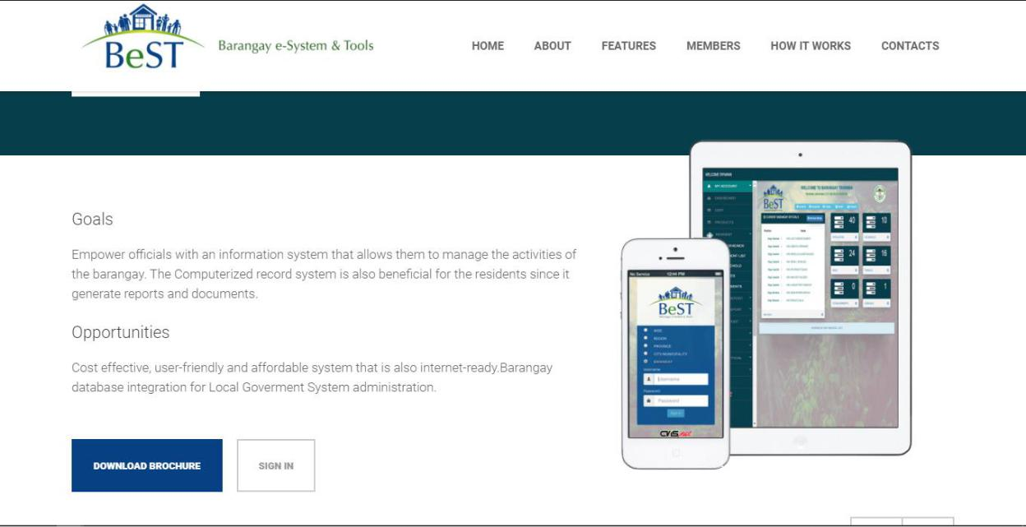

Figure 2: **BeST Barangay System**

BeST is a Barangay e-System that provides tools that can aide the needs to operate. This system boasts a management system for Records electronically; Information Management System for their Residents Profile, Judicial and Disaster Risk Reduction; and a Document Processing module that helps with Residents barangay clearance, Barangay ID, Business permits and transaction reports.

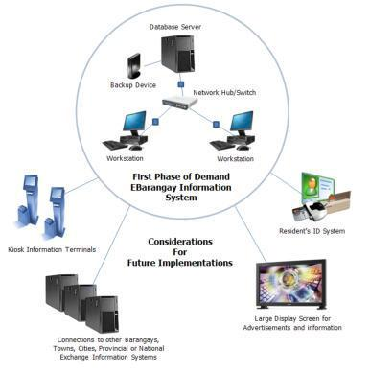

Figure 3: e-Barangay visual of their functionality

The objective of OnDemand eBarangay Information System is to organized local barangay information into a media where information becomes readily available and accessible upon demand or request. Since local information cannot just be acquired anywhere, the need to build the information in electronic format is required. Guidelines and procedures are in place in order to attain this objective. History and previous information together with the current events and other information that is shared publicly will be encoded or scanned and saved in the system. Logged books can still be in used and information is updated in the system. Thus, a dictionary or encyclopedia will be created and continuously updated as reference for current and future times. The contents of the eBarangay Information System will be a legacy for the future generations.

Building of information from the barangay level is a better way to create a database of residents' information. Barangay database can be linked or shared to a bigger database system where selected information is made available to the public. Information from the barangay can be scaled to municipality, provincial or event national

Having online information for the locality offers a lot of benefits not only to the local constituents but to visiting guests and future generations. Information can be used to create statistics, a tool for progress and event in the management of the local barangay. Partner eBIS with and ID system where unique number is assigned per individual can help crime prevention or event offers job opportunities to individuals where mix and match search can be requested.

Table 1

Comparative Matrix

|  |  |  |  |
| --- | --- | --- | --- |
|  | BeST | WarpVision ISS | eBarangay |
| Manage Account | **✓** | **✓** | **✓** |
| Manage Compaints |  |  | **✓** |
| Manage Requests |  |  | **✓** |
| Request Documents | **✓** | **✓** | **✓** |
| Profiling | **✓** |  | **✓** |
| Purok Integration | **✓** |  | **✓** |
| Public eBoard |  |  | **✓** |
| Schedule Activities |  |  | **✓** |
| Geographical View |  |  | **✓** |
| Create Organization/Groups |  |  | **✓** |
| Voting System |  |  | **✓** |

**CHAPTER III – RESEARCH METHODOLOGY**

**Scope and Limitations**

This study focuses on developing a web and mobile-based platform for management system. This system will help mentioned barangay officials manage residents records, complaints, reports, and document requests. In addition, residents can receive notifications and be able to submit document request, complaints, and their votes on the ongoing election. This study will be first conducted here in Mandaue City.

The limitations of eBarangay are the following:

* The system cannot verify if the details inputted by the residents for their profile is accurate.
* The system will not handle the management of organizations.
* The system will not handle the printing of the requested documents.
* The system will only handle minor reklamos
* The proposed study will only focus on barangays within the Mandaue City area.
* The system is not compatible with IOS.
* Android 4.0.3 and higher for Mobile devices.
* Windows 7 and higher for desktop/web.

**Software Engineering Methodology**

Software Engineering Methodology is a series of systematic process used in software projects. It comprises features of either building in a sequence, refining of current versions or tweaking of the system.

Iterative model design is a particular design that is broken down into iterations. It starts with the requirements where system related information is gathered and analyzed. Then the design phase is next, to utilized the design of the system. After that is the implementation phase, coding process is involved and executed from the designs and specifications to implement the initial iterations. Testing phase will then be done to test the code that was implemented. This is to identify and locate potential bugs and issues. Evaluation is the final phase of the iterative model design. This is to examine the project status and validate the initial requirements as well as the suggestions for the next possible iteration.

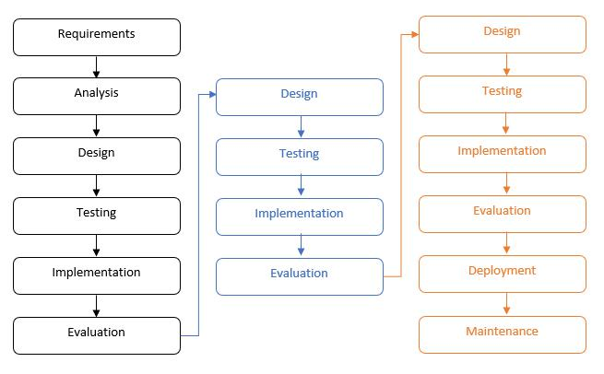

Figure 4: **Iterative Model – Design**

Iterative model design is a cycle of various processes or phases when implementing a software project. Each of the phases are iterated, starting from designs and developments, to having to test and evaluate the system, identify further requirements. Having to base on the evaluation of the previous product, you can identify the requirements needed to either maintain or improve the system.

The model starts not with the full requirements but basic ones like design and development. They are used first to make the initial iteration, once developed, it is then evaluated to define or to decide the next iteration. The process is repeated to improve and develop the software until they come to a conclusion where no further requirements are needed.

**Planning Phase**

**Business Model Canvas**

Business Model Canvas is a strategic management and lean startup template for developing new or documenting existing business models. It is a great tool to help us understand a business model in a straightforward, structured way. It is a visual chart with elements describing a product’s value proposition, infrastructure, customers, and finances.

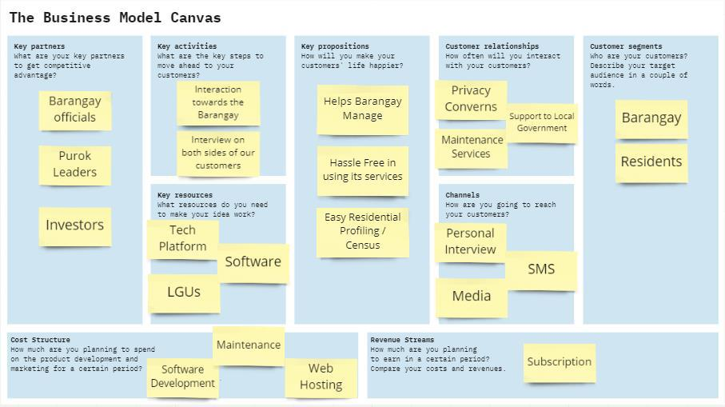Figure 5: **Business Model Canvas**

The figure above is the business model canvas used by the eBarangay. There are two customer segments involved: Barangay and Residents. As for Residents, they need to register in order to gain access to the services, while initial Barangay users will have their accounts be assigned their respective user type by the admin. The revenue streams rely on the subscriptions from barangays who want to use the system, and service charges from every document requests.

**Program Workflow**

A program workflow is a demonstration of an application that represents a step-by-step process of software that is executed accordingly.

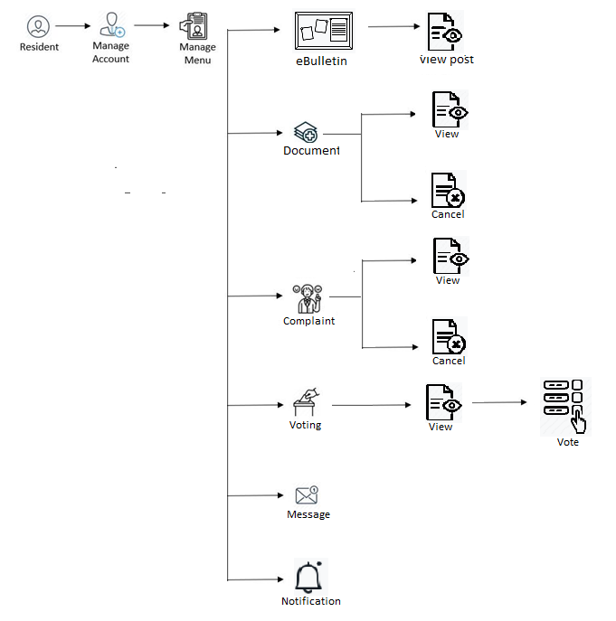**Web Program Workflow**

Figure 6: **Resident – Web Workflow**

The figure above is the program workflow for the resident. The Residents can check her account and edit information. They have access to request document and send complaints to the purok leader. The eBulletin is The eBulletin is visible to the resident account, yet they cannot post. They can send message and receive notification. They are also able to see the nominees created by the captain which residents can vote.

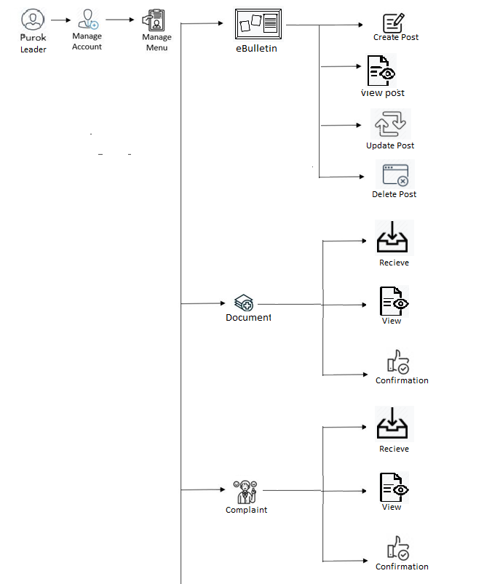

Figure 7.1: **Purok Leader – Web Workflow**

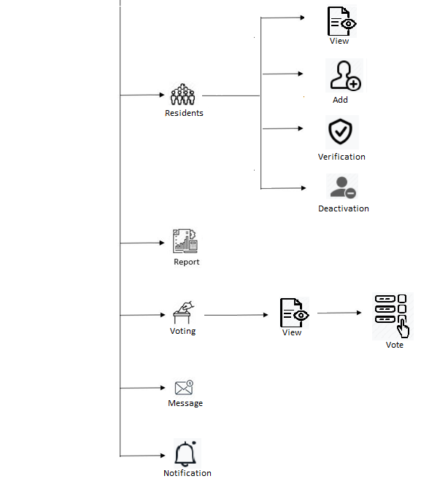Figure 7.2: **Purok Leader – Web Workflow**

The figure above is the program workflow for the puro leader. They can post their announcements on eBulletin which can also edit or delete their post. Purok leaders confirms the status of received requests and complaints from the residents. Every purok leader can view their residents’ general information. They can also choose on which candidate wanted to vote. They can send message and receive notification. Purok leaders also creates reports.

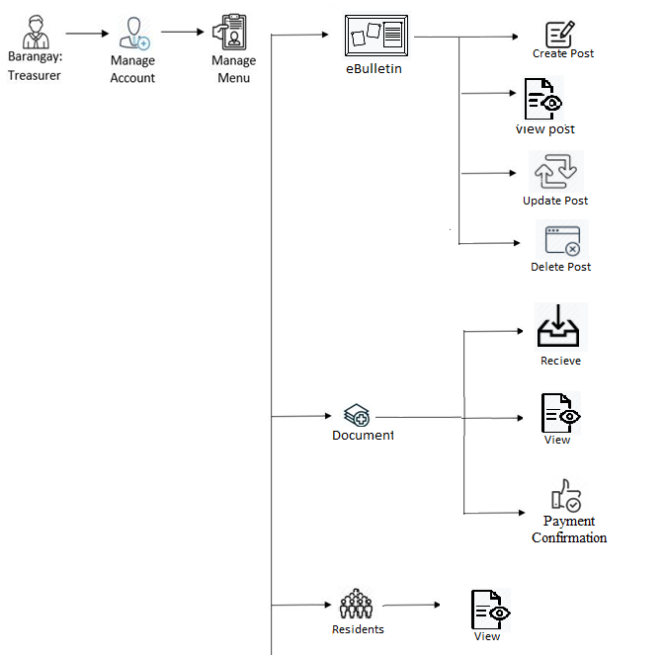

Figure 8.1: **Treasurer – Web Workflow**

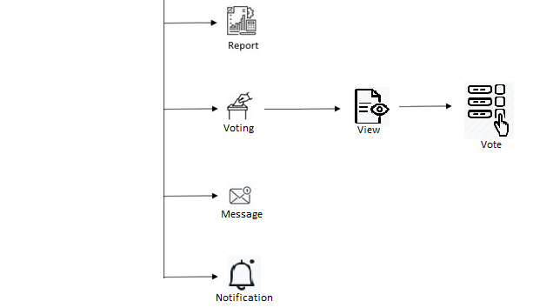Figure 8.2: **Treasurer – Web Workflow**

The figure above is the program workflow for the barangay treasurer. The barangay Treasurer can check on their account. They can post their announcements on eBulletin which they can also edit or delete their post. Treasurer confirms the payment status of received requested document. Treasurer can view residents’ general information. And can also choose on which candidate to vote. Treasurer can send message and receive notification and creates report.

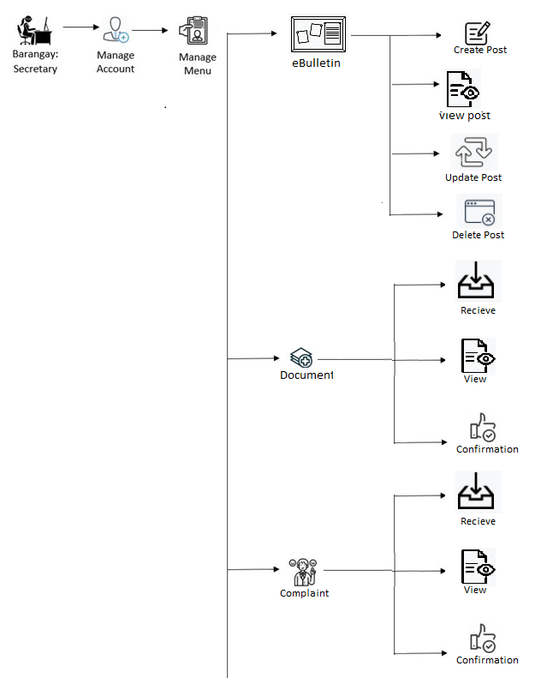Figure 9.1: **Secretary – Web Workflow**

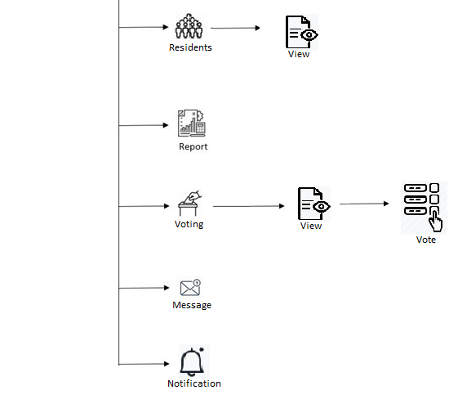Figure 9.2: **Secretary – Web Workflow**

The figure above is the program workflow for the barangay secretary. The user can post their announcements on eBulletin which can also edit or delete their post. Secretary confirms the status of received requests and complaints for them to record and report. Secretary can view their residents’ general information by purok. The user can also choose on which candidate wanted to vote. They can send message and receive notification.

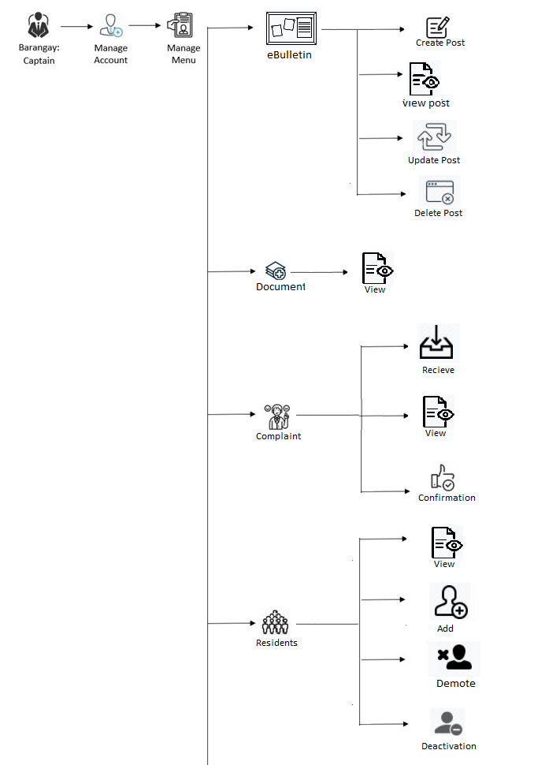Figure 10.1: **Captain – Web Workflow**

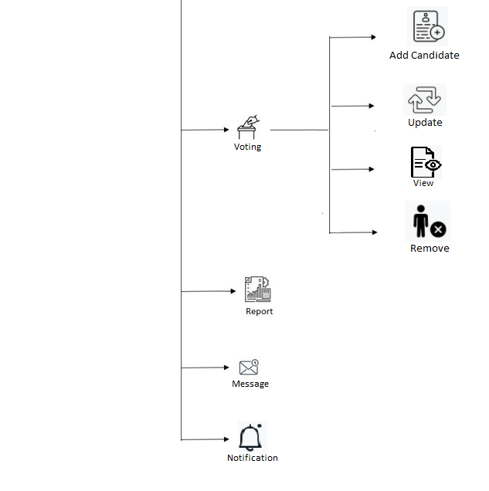Figure 10.2: **Captain – Web Workflow**

The figure above is the program workflow for the barangay captain. The barangay Captain have access to check on their account. The user can post their announcements on eBulletin which can also edit or delete their post. Captain can be able to view the requested documents. And confirms the status of complaints for them to record and report. A resident can be added, an official can be demoted or an account can be deactivated through the access of the Captain. They can also manage the voting through adding which other users can vote or removing a nominee. Captain can view their residents’ general information by purok. They can send message and receive notification.

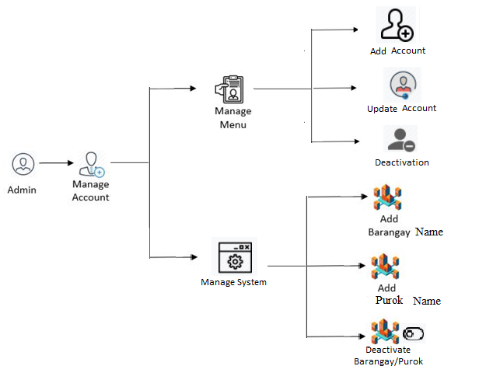

Figure 11: **Admin – Web Workflow**

The figure above is the program workflow for the admin. The admin can manage account through adding, updating or deactivating an account for the user. Admin assigns account for the barangay officers. The admin can add new barangay and purok name in the system, as well as deactivating a barangay or purok name.

**Mobile Program Workflow**

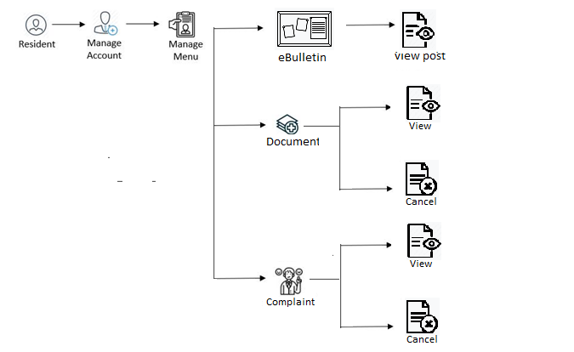

Figure 12: **Resident – Mobile Workflow**

The figure above is the program workflow for the resident on mobile which user can manage account. Resident can view on posted announcements through eBulletin. They can also check on their documents and complaints.

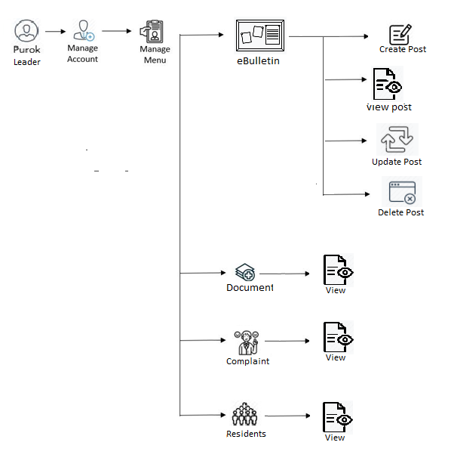

Figure 13: **Purok Leader – Mobile Workflow**

The figure above is the program workflow for the purok leader on mobile which user can manage account. Purok leaders on mobile can post or delete announcements through eBulletin. They can also view on their documents, complaints and residents.

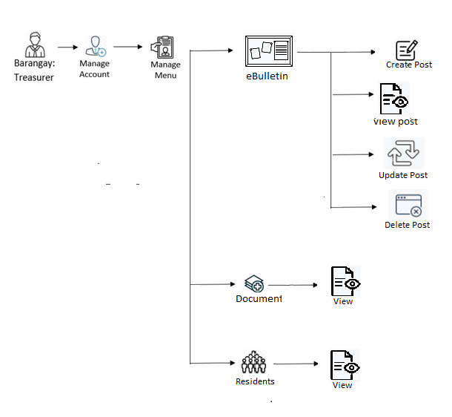

Figure 14: **Treasurer – Mobile Workflow**

The figure above is the program workflow for the treasurer on mobile which user can manage account. Treasurer on mobile can post or delete announcements through eBulletin. They can also view on their documents and complaints.

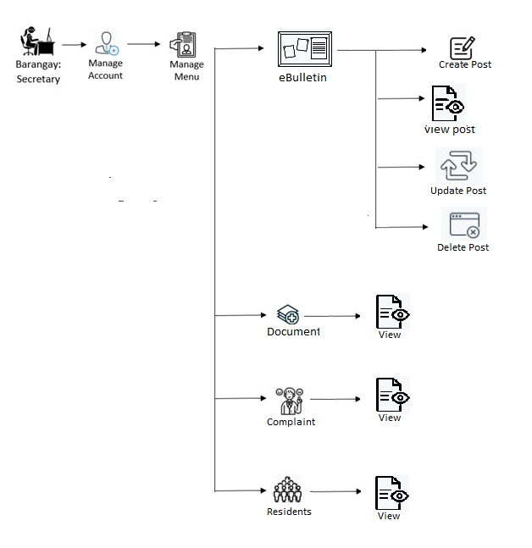

Figure 15: **Secretary – Mobile Workflow**

The figure above is the program workflow for the secretary on mobile which user can manage account. secretary on mobile can post or delete announcements through eBulletin. They can also view on their documents, complaints and residents.

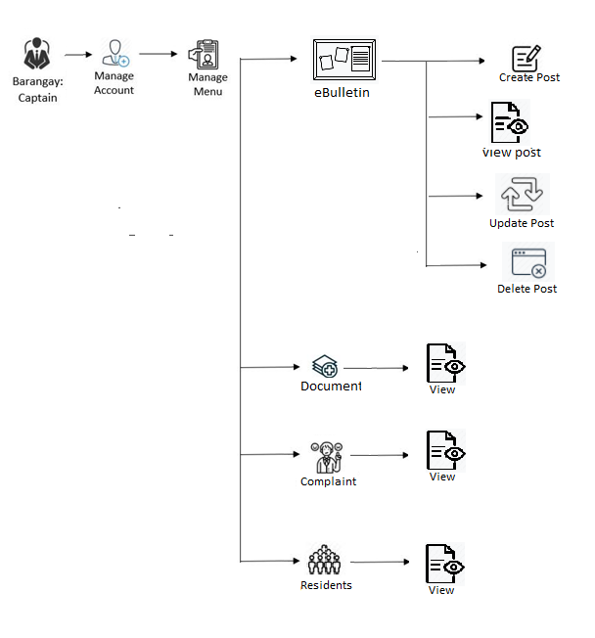Figure 16: **Captain – Mobile Workflow**

The figure above is the program workflow for the barangay captain on mobile which user can manage account. Barangay captain on mobile can post or delete announcements through eBulletin. User can also view on their documents, complaints and residents.

**Gantt Chart**

These is the Gantt chart of the researchers which shows the amount of work done or production completed in certain periods of time in relation to the amount planned for those periods.

Table 2

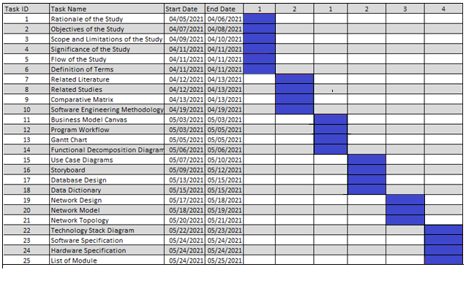Capstone 1 Gantt Chart: Projected

Table 3

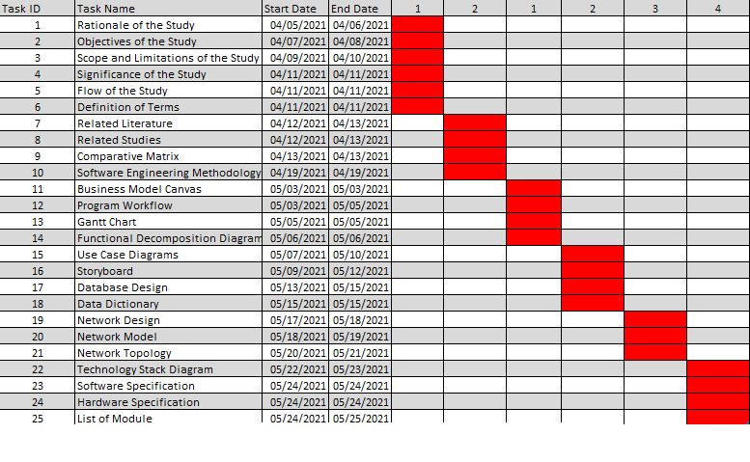Capstone 1 Gantt Chart Completed

Table 4

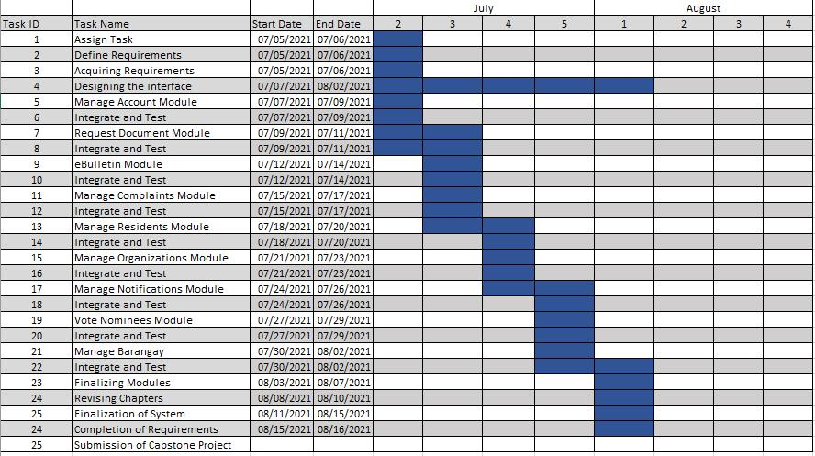Capstone 2 Gantt Chart: Projected

Table 5

Capstone 2 Gantt Chart: Completed

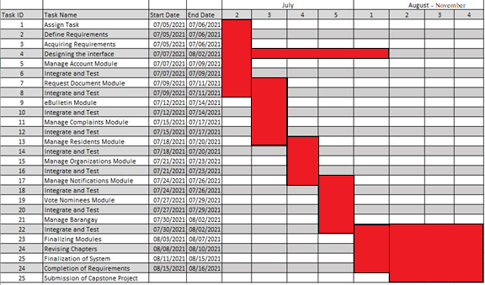

**Functional Decomposition Diagram**

Functional decomposition is defined as a top-down representation of process or function. The Functional Decomposition Diagram shows that there are eight managements which are: Services, Profiling, Accounts, Information, Organization, Complaints, Barangay, and Voting. These managements can be accessed by varied users. The legend shows you which functionalities are accessed by whom. Basically, this is used for representing business function and operation in hierarchical manner.

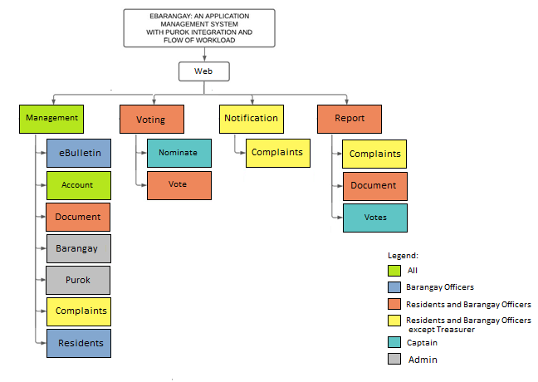Figure 17.1: **Web - Functional Decomposition Diagram**

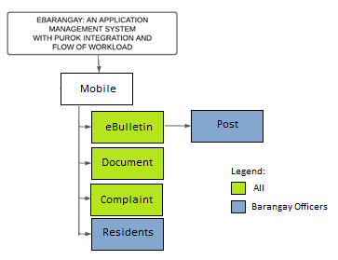

Figure 18: **Mobile - Functional Decomposition Diagram**

**Analysis Phase**

**Use-Case Diagram**

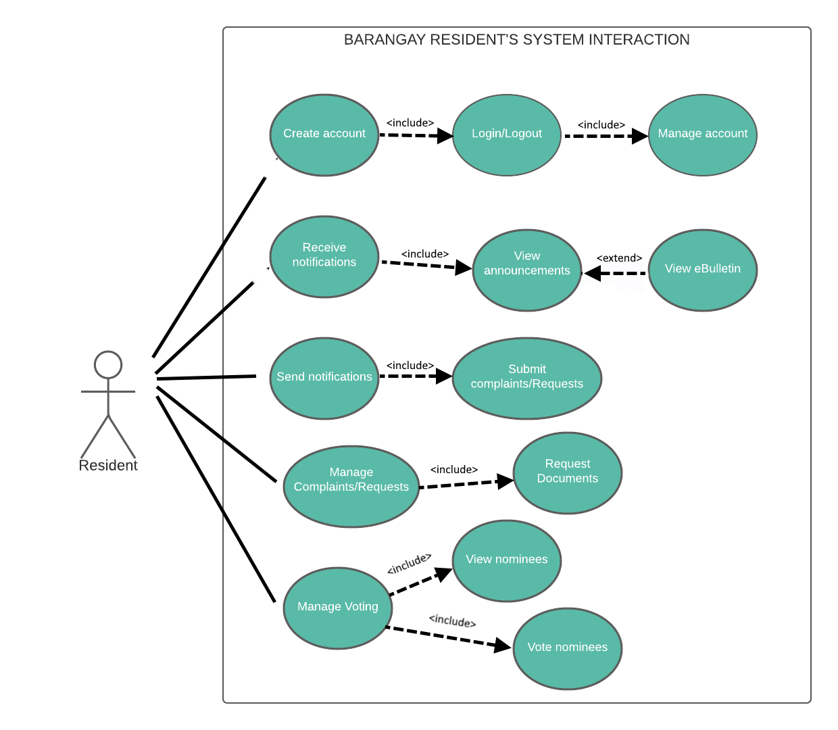

Figure 19: **Resident – Use-Case Web**

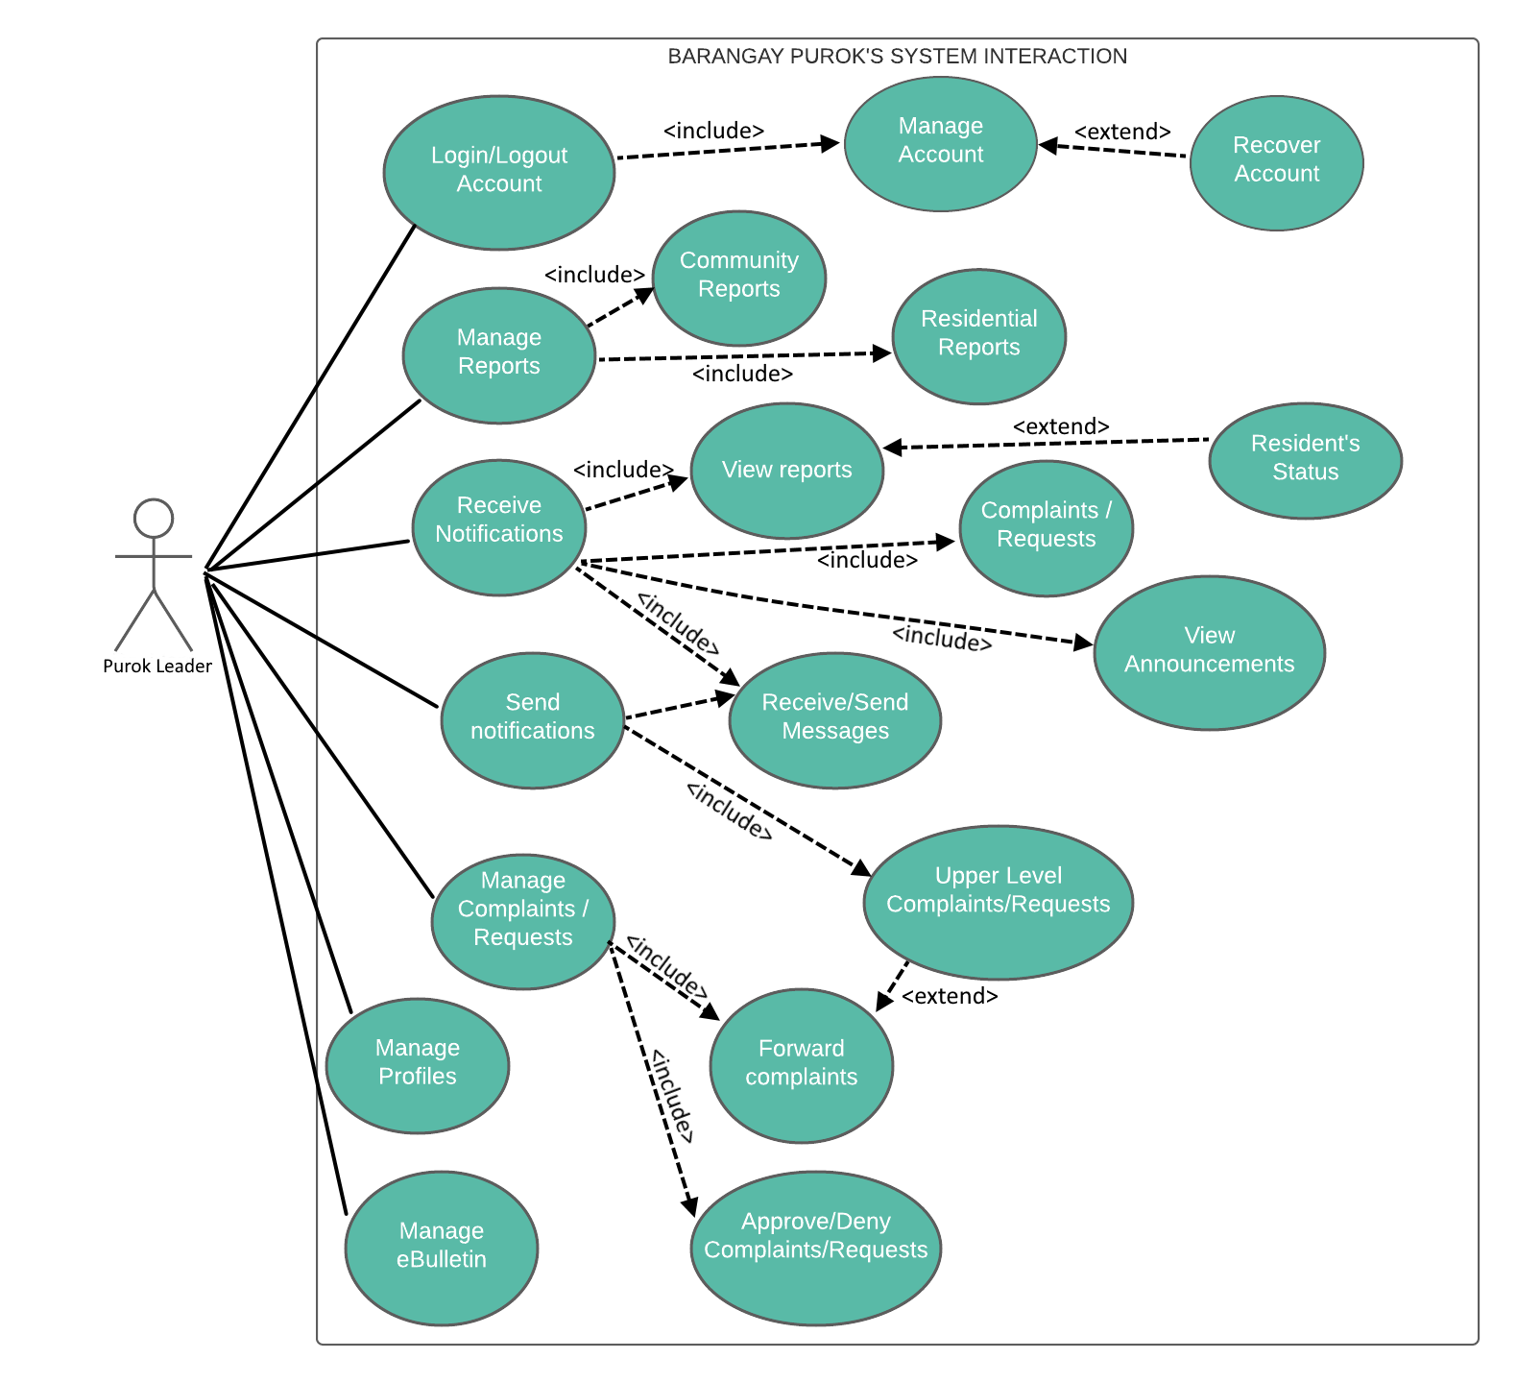

Figure 24: **Purok Leader – Use-Case Web**

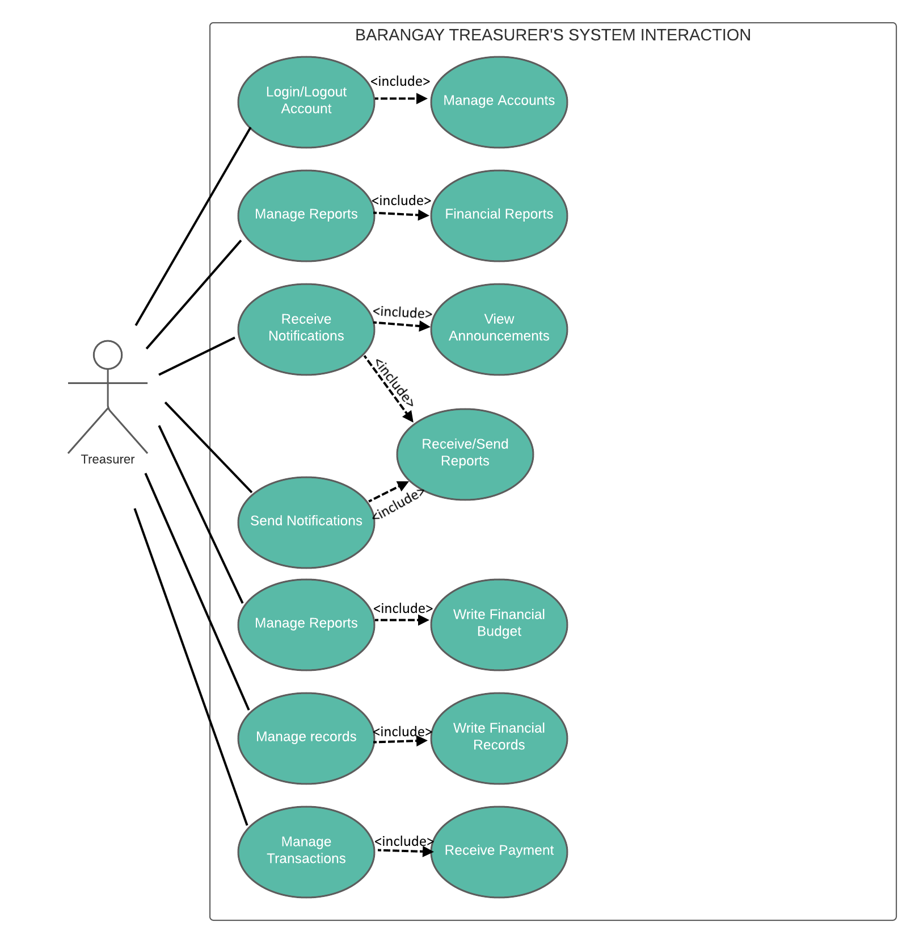

Figure 20: **Treasurer – Use-Case Web**

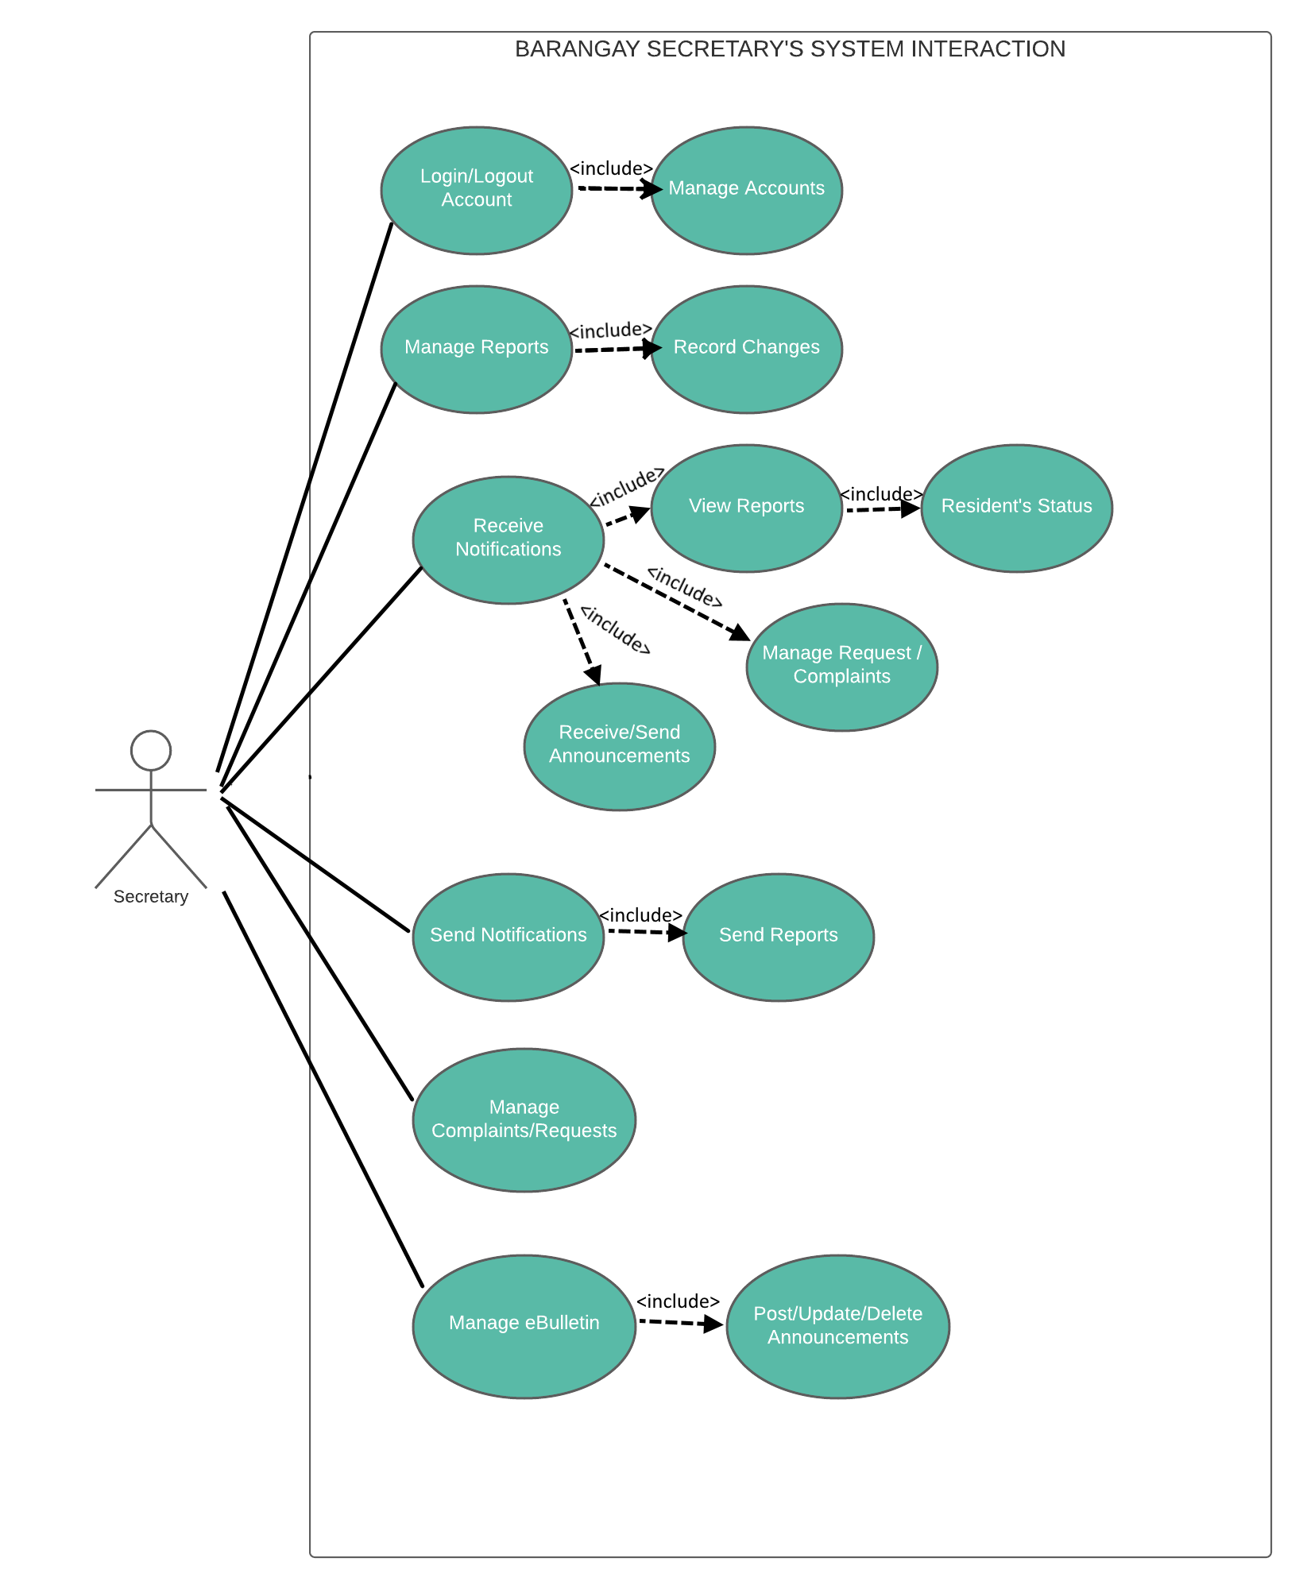

Figure 21: **Secretary – Use-Case Web**

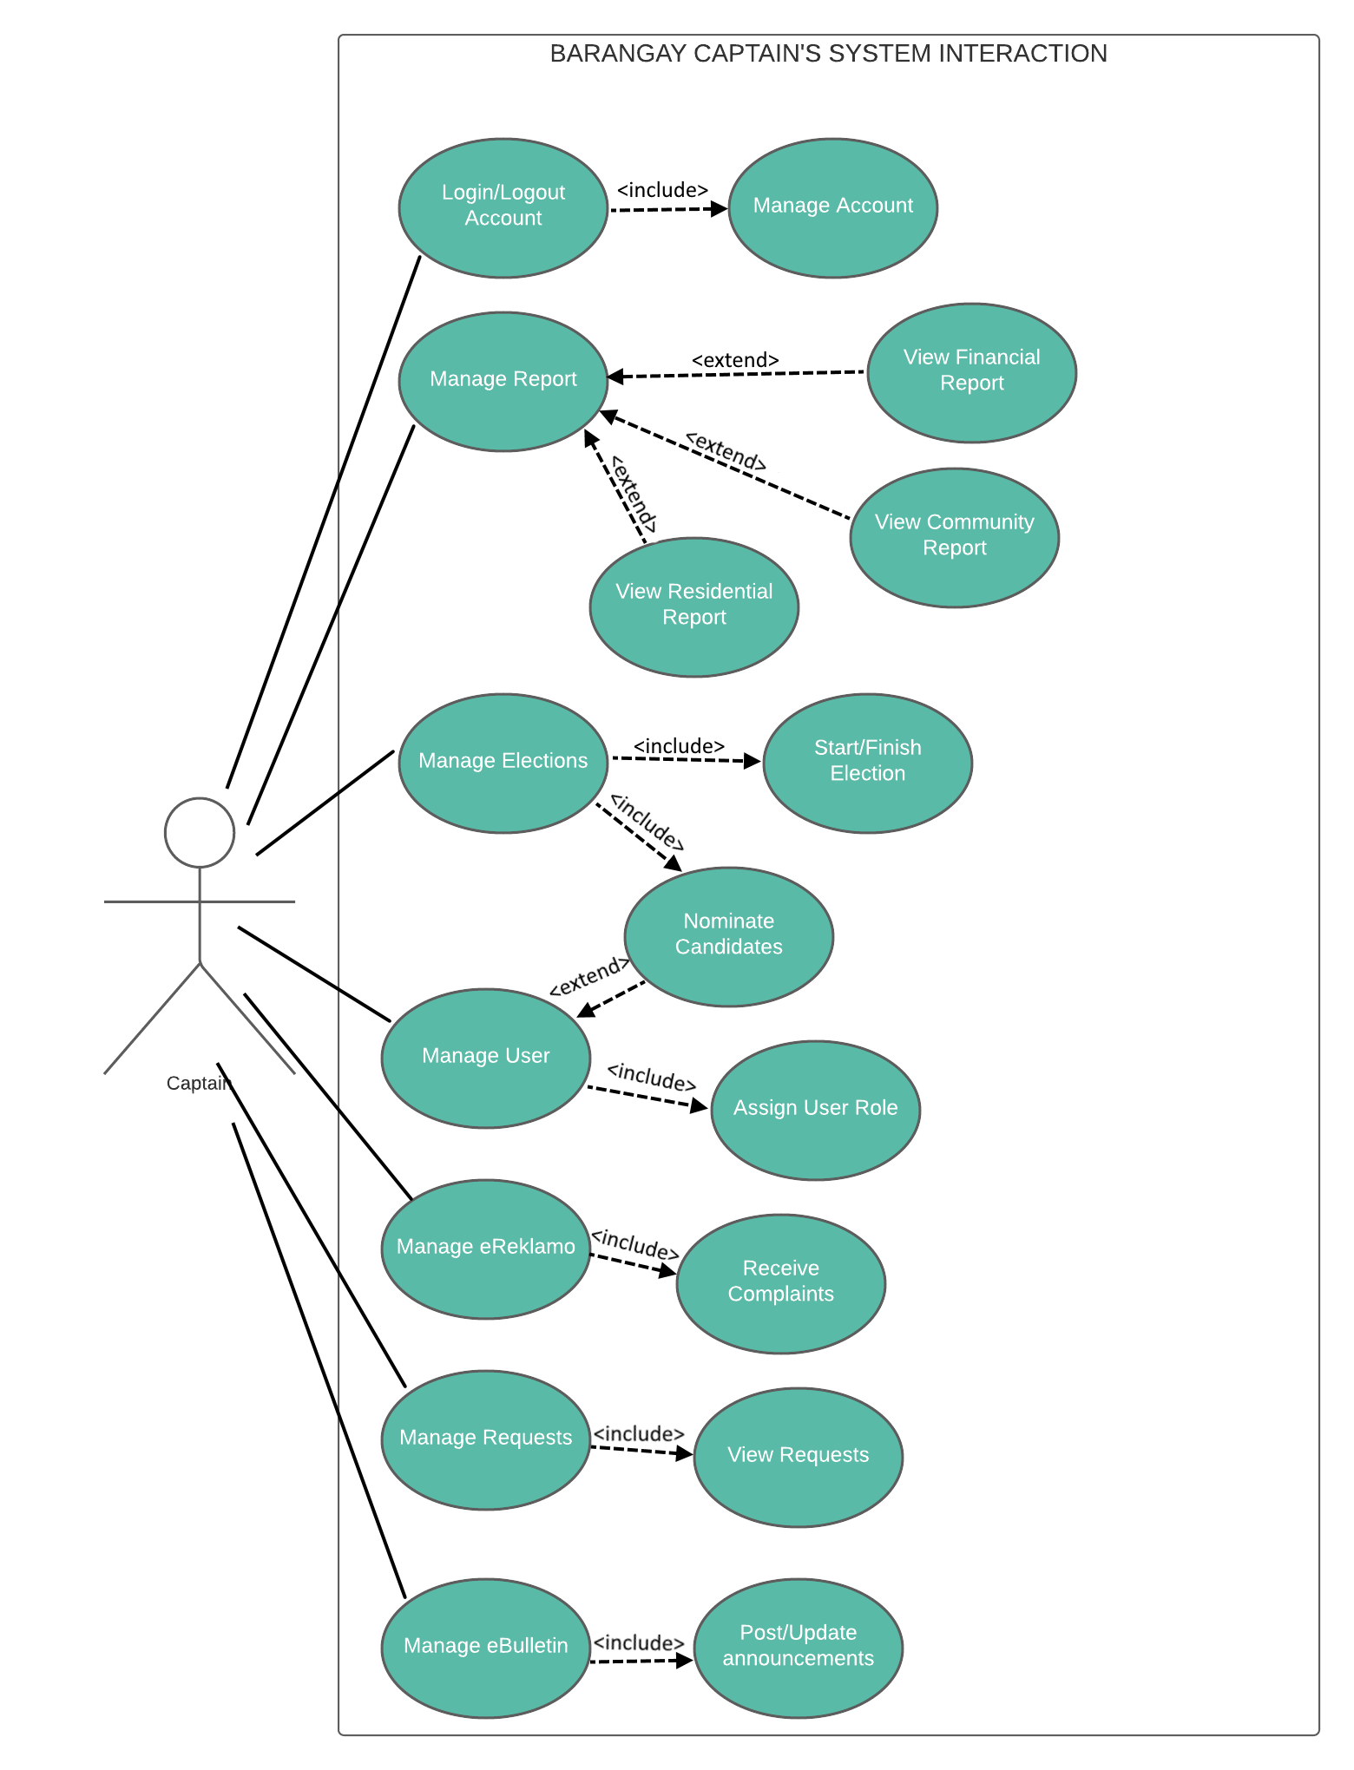

Figure 22: **Captain – Use-Case Web**

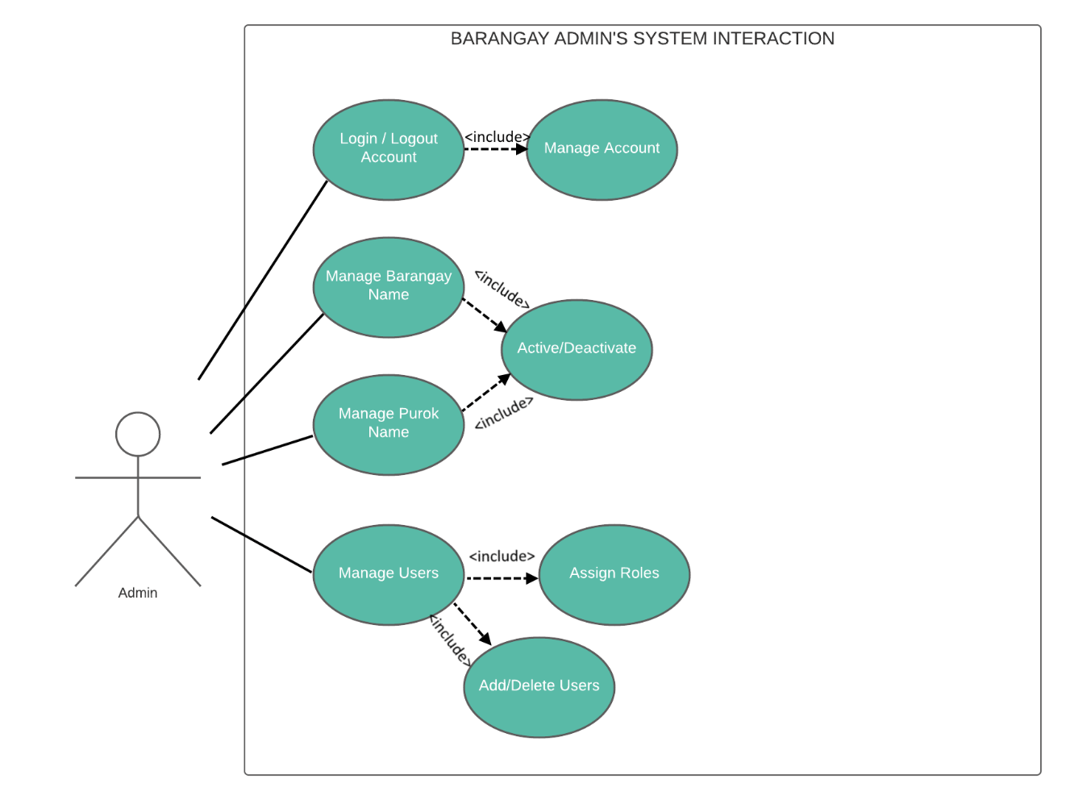

Figure 23: **Admin – Use-Case Web**

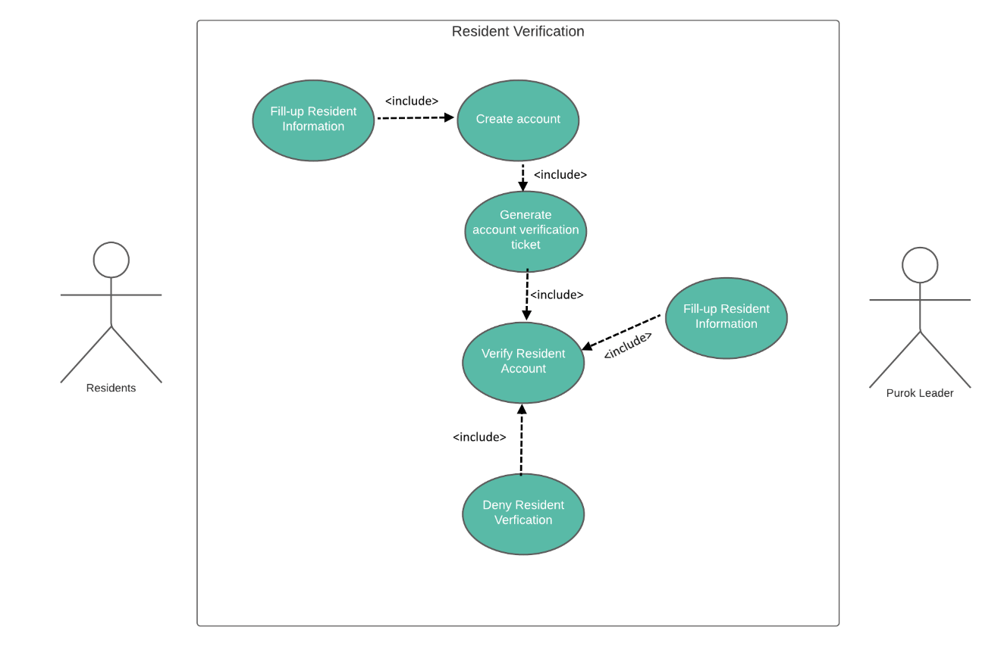Figure 25: **Resident Verification – Use-Case Web**

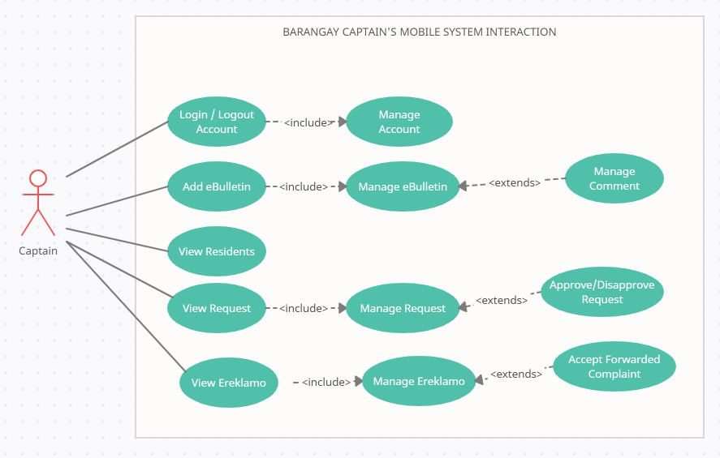Figure 26: **Captain – Use-Case Mobile**

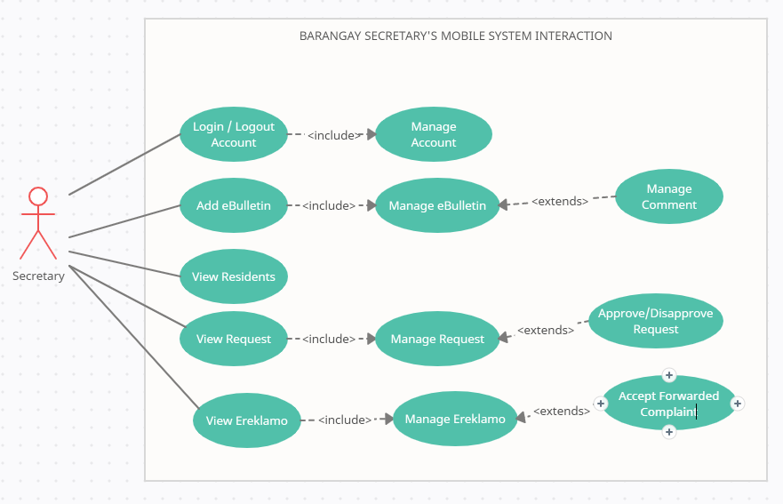

Figure 27: **Secretary – Use-Case Mobile**

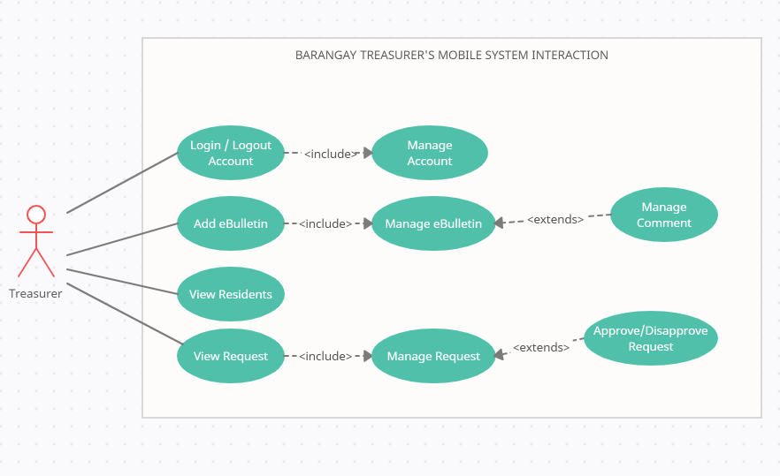

Figure 28: **Treasurer – Use-Case Mobile**

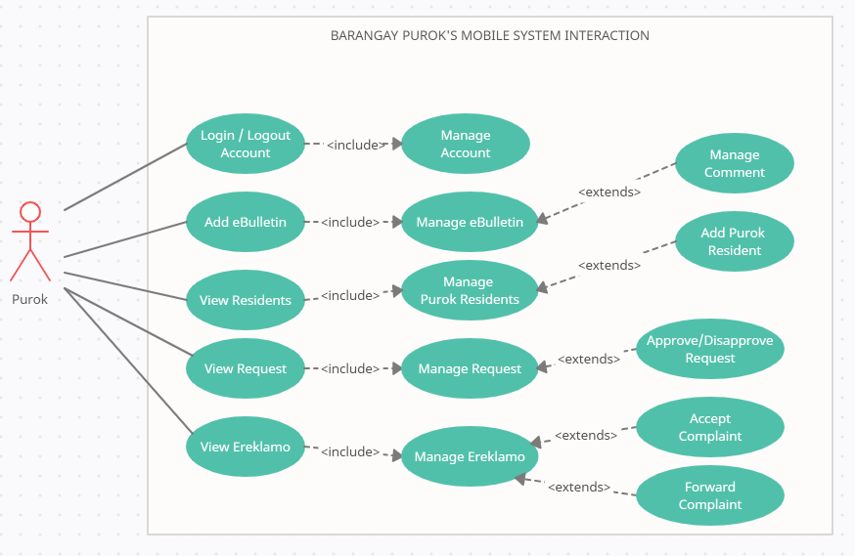

Figure 29: **Purok Leader – Use-Case Mobile**

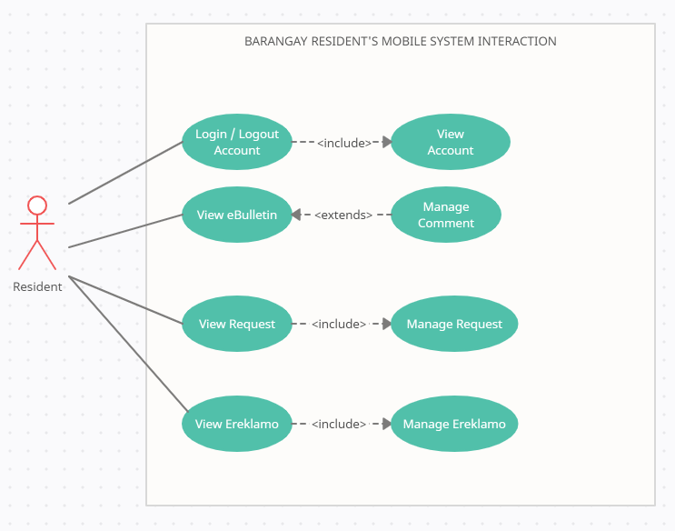

Figure 30: **Resident – Use-Case Mobile**

**Storyboard**

**Web**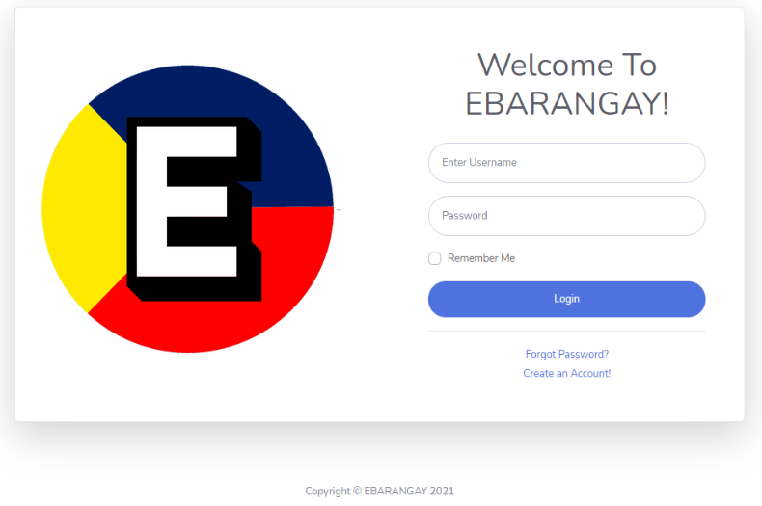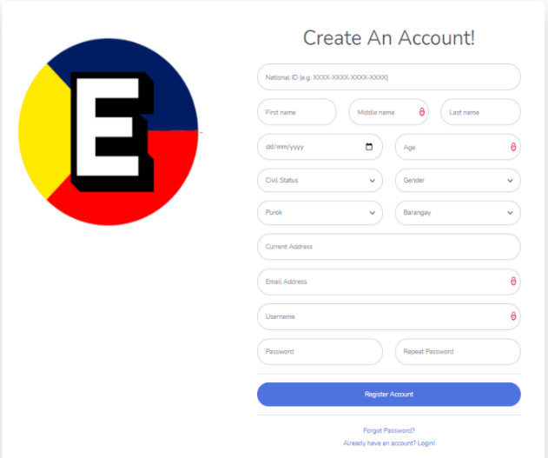

Figure 31: Storyboard – Register Page Figure 32: Storyboard – Register Page

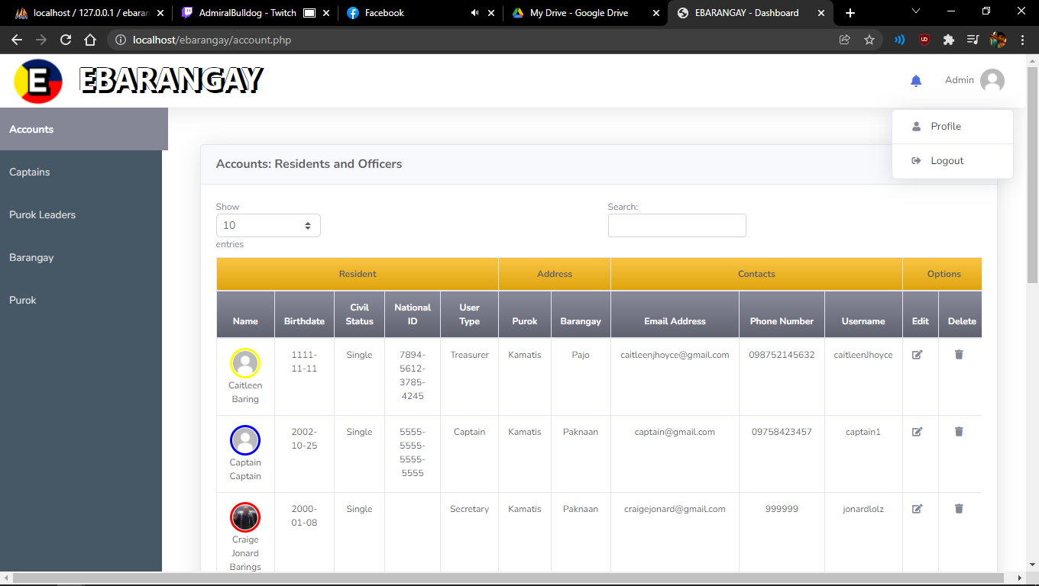

Figure 33: Storyboard – Admin Page

d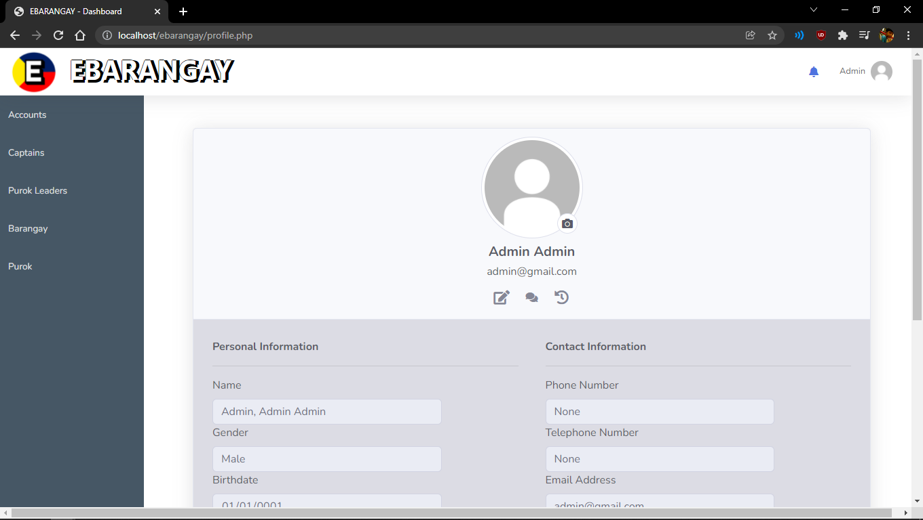

Figure 34: Storyboard – Profile Page

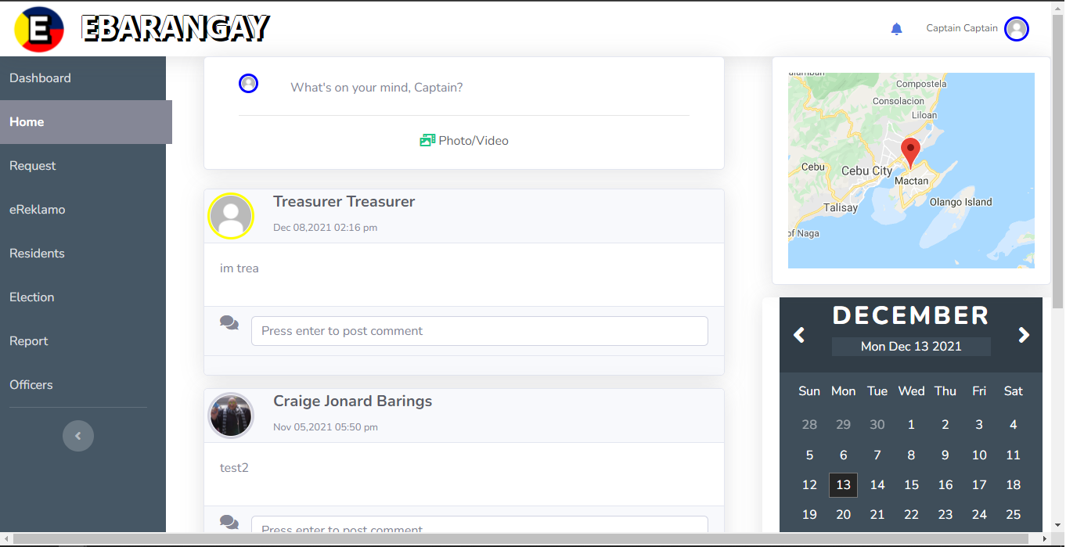

Figure 35: Storyboard – eBulletin Page

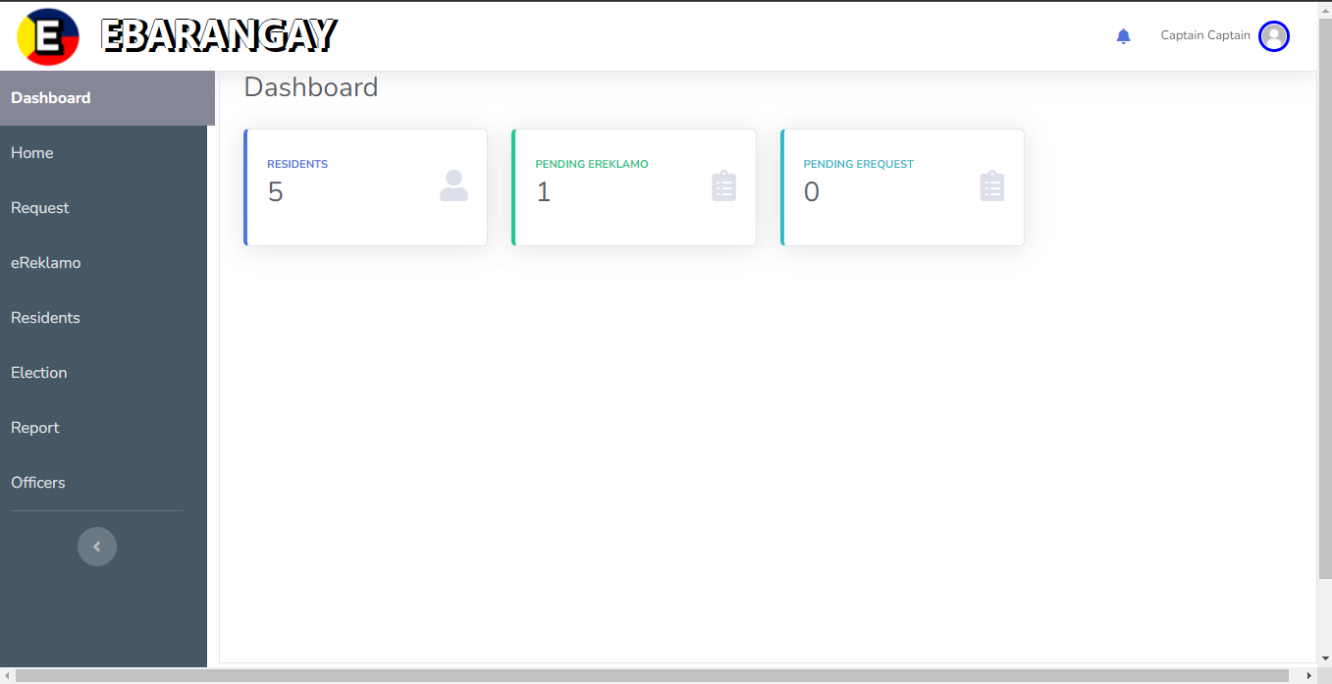

Figure 36: Storyboard – Dashboard Page

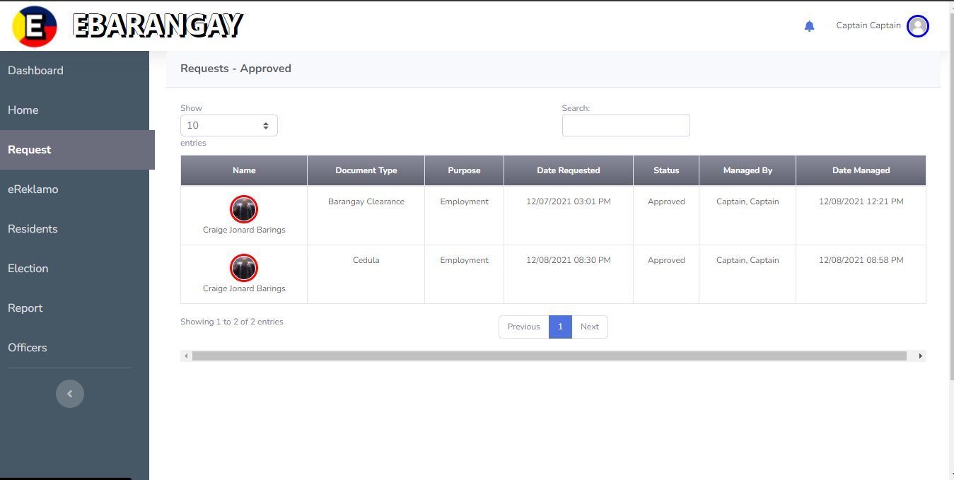

Figure 37: Storyboard – Request Page

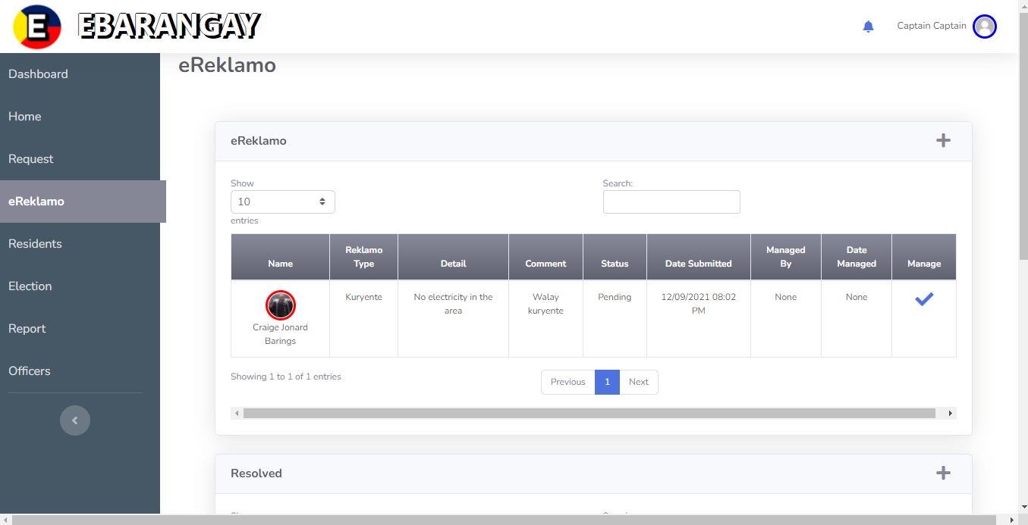

Figure 38: Storyboard – eReklamo Page

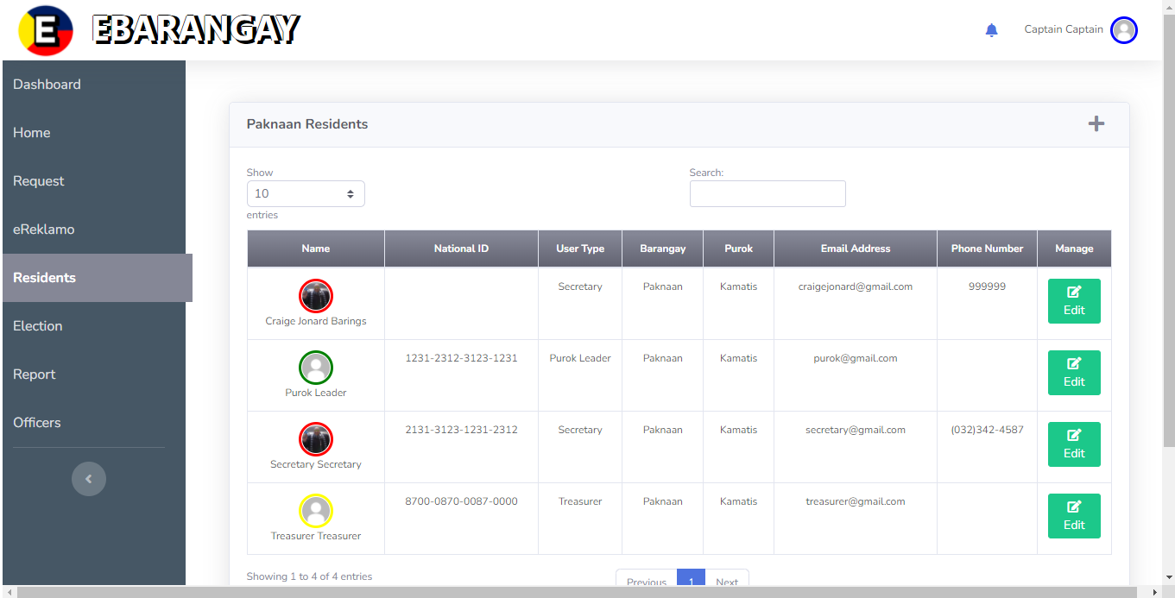

Figure 39: Storyboard – Residents Page

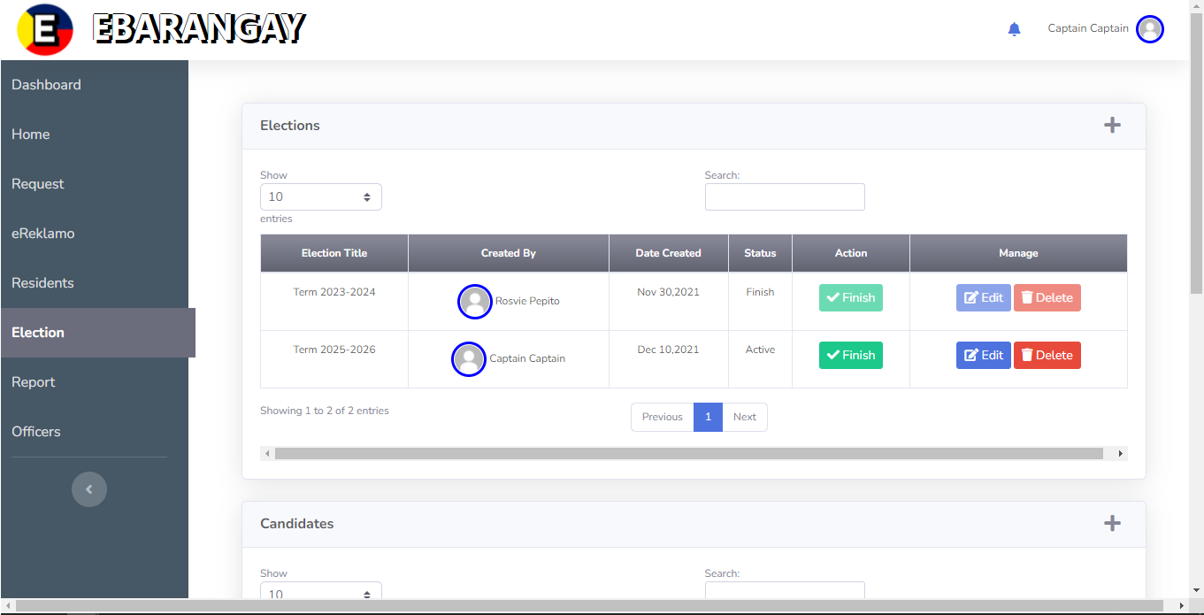

Figure 40: Storyboard – Election Page

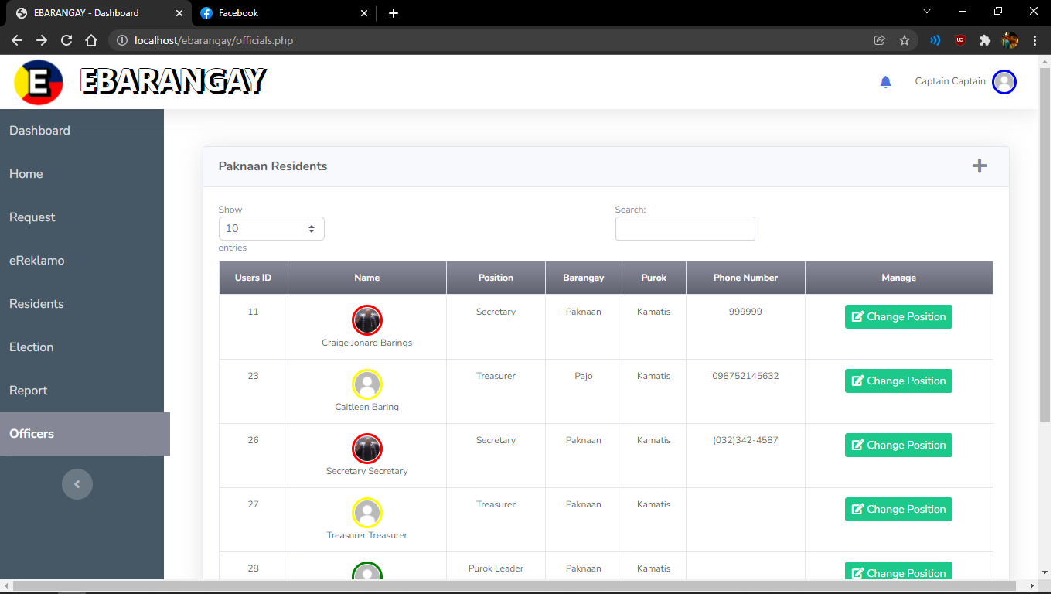

Figure 41: Storyboard – Officers Page

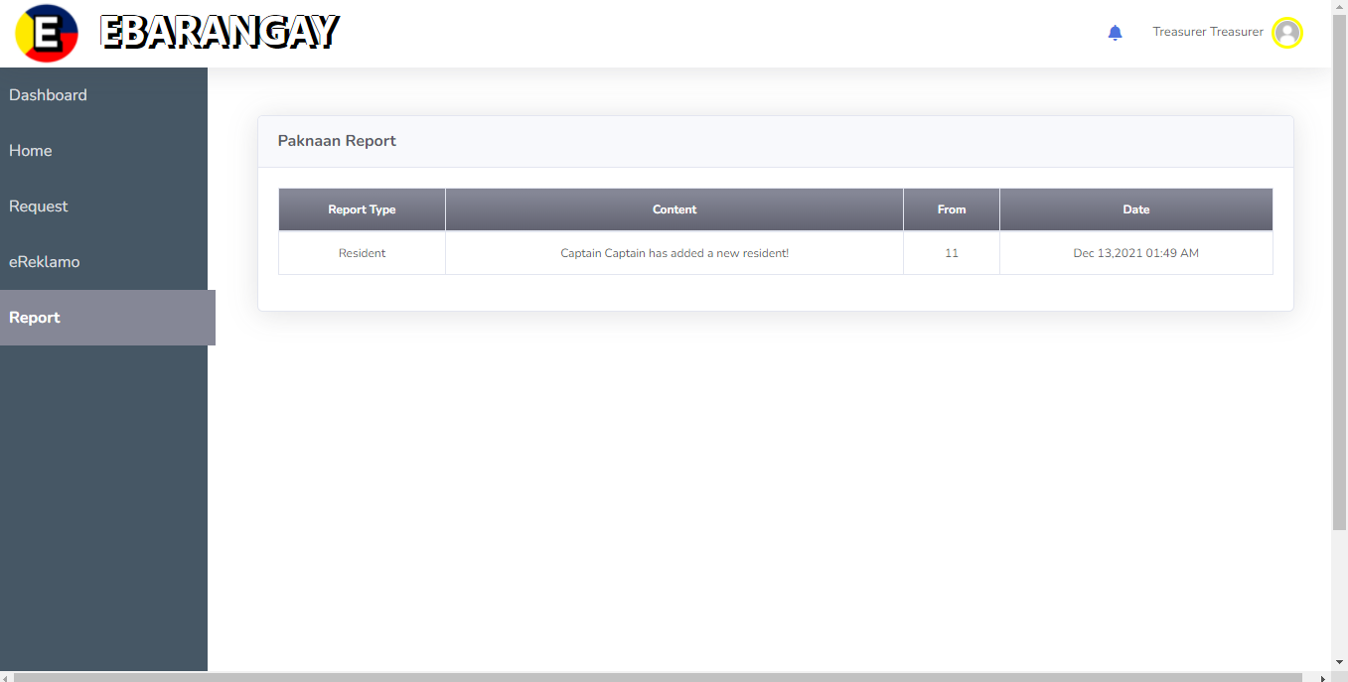

Figure 42: Storyboard – Report Page

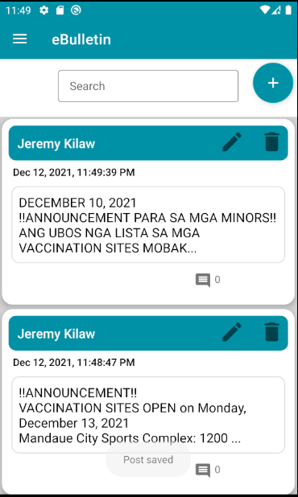**Mobile**

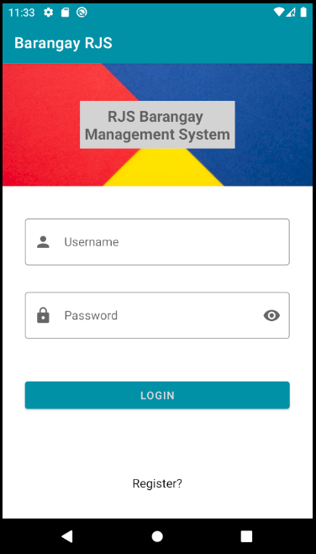

Figure 43: **Storyboard – Login Page Mobile** Figure 44: **Storyboard – eBulletin Page Mobile**

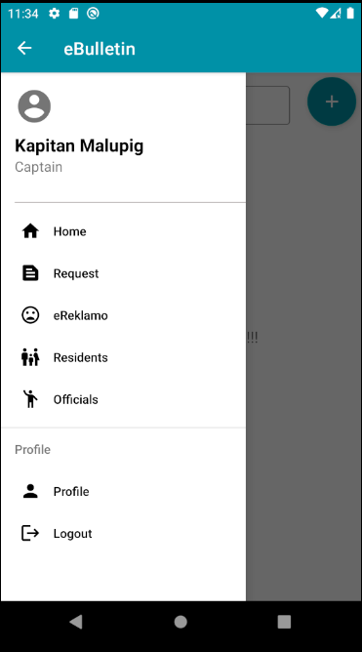 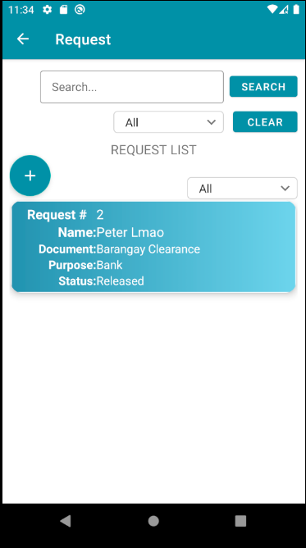

Figure 45: **Storyboard – Drawer Menu Page** Figure 46: **Storybaord – Request Page Mobile**

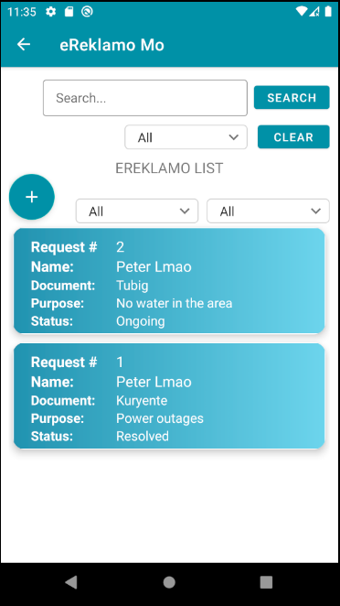 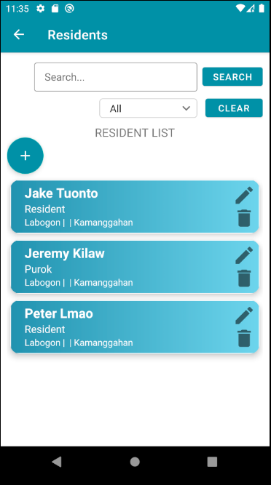

Figure 47: **Storyboard – eReklamo Page Mobile** Figure 48: **Storyboard – Resident Page Mobile**

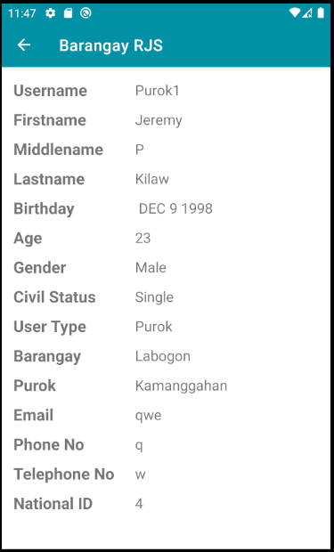

Figure 49: **Storyboard – Profile Page Mobile**

**Database Design**

**Entity-Relationship Diagram**

An entity relationship diagram (ERD) shows the relationships of entity sets stored in a database. An entity in this context is an object, a component of data. An entity set is a collection of similar entities. These entities can have attributes that define its properties.

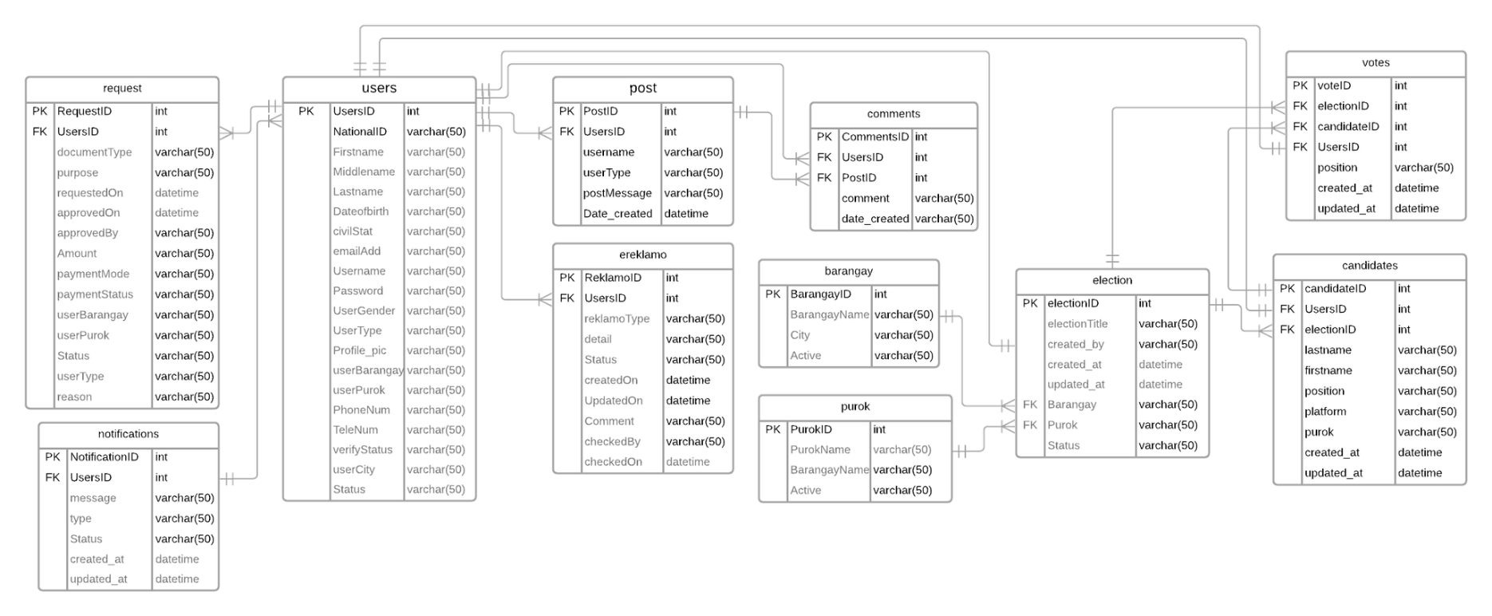Figure 50: **Entity-Relationship Diagram**

**Data Dictionary**

A data dictionary is a collection of the names, definitions, and attributes for data elements and models. The data in a data dictionary is the metadata about the database. These elements are then used as part of a database, research project, or information system.

Table 6

Data Ditionary

|  |  |  |  |  |  |  |  |  |
| --- | --- | --- | --- | --- | --- | --- | --- | --- |
| Table Name | Attribute Name | Contents | Type | Format | Range | Required | PK or FK | FK REFERENCED TABLE |
| Users | UsersID | User ID | INT(11) | 00000000000 | 00000000001-9999999999 | Y | PK |  |
| NationalID | Resident’s National ID | VARCHAR(50) | Xxxx xxxx |  | Y |  |  |
| Firstname | Resident’s Firstname | VARCHAR(50) | Xxxx xxxx |  | Y |  |  |
| Middlename | Resident’s Middlename | VARCHAR(50) | Xxxx xxxx |  | N |  |  |
| Lastname | Resident’s Lastname | VARCHAR(50) | Xxxx xxxx |  | Y |  |  |
| Dateofbirth | Date of Birth | VARCHAR(50) | Xxxx xxxx |  | Y |  |  |
| civilStat | Civil Status | VARCHAR(50) | Xxxx xxxx |  | Y |  |  |
| emailAdd | Email Address | VARCHAR(50) | Xxxx xxxx |  | Y |  |  |
| Username | Username | VARCHAR(50) | Xxxx xxxx |  | Y |  |  |
| Password | Password | VARCHAR(50) | Xxxx xxxx |  | Y |  |  |
| userGender | Gender | VARCHAR(50) | Xxxx xxxx |  | Y |  |  |
| userType | User Type | VARCHAR(50) | Xxxx xxxx |  | Y |  |  |
| Profile_pic | Profile Picture | VARCHAR(50) | Xxxx xxxx |  | Y |  |  |
| userBarangay | User’s Barangay | VARCHAR(50) | Xxxx xxxx |  | Y |  |  |
| userPurok | User’s Purok | VARCHAR(50) | Xxxx xxxx |  | Y |  |  |
| PhoneNum | Phone Number | VARCHAR(50) | Xxxx xxxx |  | Y |  |  |
| TeleNum | Tele Number | VARCHAR(50) | Xxxx xxxx |  | Y |  |  |
| verifyStatus | Status of verification | VARCHAR(50) | Xxxx xxxx |  | Y |  |  |
| userCity | User’s City | VARCHAR(50) | Xxxx xxxx |  | Y |  |  |
|  | Status | Account status, active or inactive | VARCHAR(50) | Xxxx xxxx |  |  |  |  |
| Post | PostID | Post’s ID | INT(11) | 00000000000 | 00000000001-9999999999 | Y | PK |  |
|  | UsersID | User’s ID | INT(11) | 00000000000 | 00000000001-9999999999 | Y | FK | Users |
|  | Username | Username | VARCHAR(50) |  |  | Y |  |  |
|  | userType | User Type | VARCHAR(50) |  |  | Y |  |  |
|  | postMessage | Message of the post | DATETIME | MM/DD/YY hh:mm:ss |  | Y |  |  |
|  | Date_created | Date of creation of post | DATETIME | MM/DD/YY hh:mm:ss |  | Y |  |  |
| Comments | CommentsID | Comment’s ID | INT(11) | 00000000000 | 00000000001-9999999999 | Y | PK |  |
|  | UsersID | Commentor’s User ID | INT(11) | 00000000000 | 00000000001-9999999999 | Y | FK | Users |
|  | PostID | PostID to where the comment was posted | INT(11) | 00000000000 | 00000000001-9999999999 | Y | FK | Post |
|  | comment | Comment content | VARCHAR(50) |  |  | Y |  |  |
|  | Date_created | Date of creation | DATETIME | MM/DD/YY hh:mm:ss |  | Y |  |  |
| Barangay | BarangayID | Barangay’s ID | INT(11) | 00000000000 | 00000000001-9999999999 | Y | PK |  |
|  | BarangayName | Barangay Name | VARCHAR(50) |  |  | Y |  |  |
|  | City | City of the Barangay | VARCHAR(50) |  |  | Y |  |  |
|  | Active | If barangay is still active | VARCHAR(50) |  |  | Y |  |  |
| Purok | PurokID | Purok’s ID | INT(11) | 00000000000 | 00000000001-9999999999 | Y | PK |  |
|  | PurokName | Purok’s Name | VARCHAR(50) |  |  | Y |  |  |
|  | BarangayName | Barangay’s Name | VARCHAR(50) |  |  | Y |  |  |
|  | Active | Barangay’s status on active or inactive | VARCHAR(50) |  |  | Y |  |  |
| eReklamo | ReklamoID | ID for eReklamo | INT(11) | 00000000000 | 00000000001-9999999999 | Y | PK |  |
|  | UsersID | UsersID for the sender | INT(11) | 00000000000 | 00000000001-9999999999 | Y | FK | Users |
|  | reklamoType | Type of Reklamo | VARCHAR(50) |  |  | Y |  |  |
|  | Detail | Detail of the reklamo submitted | VARCHAR(50) |  |  | Y |  |  |
|  | Status | Status of the reklamo | VARCHAR(50) |  |  | Y |  |  |
|  | CreatedOn | Date reklamo created | DATETIME | MM/DD/YY hh:mm:ss |  | Y |  |  |
|  | UpdatedOn | Date reklamo updated | DATETIME | MM/DD/YY hh:mm:ss |  | Y |  |  |
|  | Comment | Additional details of the reklamo | VARCHAR(50) |  |  | N |  |  |
|  | checkedBy | Barangay official name of who checked | VARCHAR(50) |  |  | Y |  |  |
|  | checkedOn | Date when it was checked | DATETIME | MM/DD/YY hh:mm:ss |  | Y |  |  |
| request | RequestID | ID of the request | INT(11) | 00000000000 | 00000000001-9999999999 | Y | PK |  |
|  | UsersID | ID of the User who submitted the request | INT(11) | 00000000000 | 00000000001-9999999999 | Y | FK | Users |
|  | documentType | Type of document | VARCHAR(50) |  |  | Y |  |  |
|  | purpose | Purpose of the request | VARCHAR(50) |  |  | Y |  |  |
|  | requestedOn | Date when it was requested | DATETIME | MM/DD/YY hh:mm:ss |  | Y |  |  |
|  | approvedOn | Date approved | DATETIME | MM/DD/YY hh:mm:ss |  | Y |  |  |
|  | approvedBy | Name of who approved | VARCHAR(50) |  |  | Y |  |  |
|  | Amount | Amount to pay | VARCHAR(50) |  |  | Y |  |  |
|  | paymentMode | Cash on delivery or Cash on Claim | VARCHAR(50) |  |  | Y |  |  |
|  | paymentStatus | If paid or not paid | VARCHAR(50) |  |  | Y |  |  |
|  | userBarangay | Barangay name where requester lives | VARCHAR(50) |  |  | Y |  |  |
|  | userPurok | Purok name where requester lives | VARCHAR(50) |  |  | Y |  |  |
|  | Status | Status if it request is pending, approved, not approved, or released | VARCHAR(50) |  |  | Y |  |  |
|  | userType | User type | VARCHAR(50) |  |  | Y |  |  |
|  | reason | Reason of not approved | VARCHAR(50) |  |  | N |  |  |
| Election | electionID | ID of election | INT(11) |  |  | Y | PK |  |
|  | electionTitle | Title of the election | VARCHAR(50) |  |  | Y |  |  |
|  | Created_by | Who created the election | VARCHAR(50) |  |  | Y |  |  |
|  | Created_at | Date of creation | DATETIME | MM/DD/YY hh:mm:ss |  | Y |  |  |
|  | Updated_at | Date of update | DATETIME | MM/DD/YY hh:mm:ss |  | Y |  |  |
|  | Barangay | Barangay name election is held | VARCHAR(50) |  |  | Y |  |  |
|  | Purok | Purok name election is held | VARCHAR(50) |  |  | Y |  |  |
|  | status | Status of the election  On Going, Finished | VARCHAR(50) |  |  | Y |  |  |
| candidates | candidateID | ID of the candidate | INT(11) | 00000000000 | 00000000001-9999999999 | Y | PK |  |
|  | UsersID | ID of the user | INT(11) | 00000000000 | 00000000001-9999999999 | Y | FK | Users |
|  | lastname | Lastname of candidate | VARCHAR(50) |  |  | Y |  |  |
|  | Firstname | Firstname of candidate | VARCHAR(50) |  |  | Y |  |  |
|  | Position | Position of candidate is nominated | VARCHAR(50) |  |  | Y |  |  |
|  | electionID | Election ID of which user is nominated | INT(11) |  |  | Y | FK | Election |
|  | Platform | Candidate’s platform | VARCHAR(50) |  |  | Y |  |  |
|  | Purok | Purok where candidate lives | VARCHAR(50) |  |  | Y |  |  |
|  | Created_at | Date when user is nominated | DATETIME | MM/DD/YY hh:mm:ss |  | Y |  |  |
|  | Updated_at | Date of update | DATETIME | MM/DD/YY hh:mm:ss |  | Y |  |  |
| Votes | voteID | Vote ID | INT(11) | 00000000000 | 00000000001-9999999999 | Y | PK |  |
|  | electionID | ID of election | INT(11) | 00000000000 | 00000000001-9999999999 | Y | FK | Election |
|  | candidateID | ID of candidate | INT(11) | 00000000000 | 00000000001-9999999999 | Y | FK | Candidate |
|  | usersID | ID of User | INT(11) | 00000000000 | 00000000001-9999999999 | Y | FK | Users |
|  | Position | Position of candidate | VARCHAR(50) |  |  | Y |  |  |
|  | Created_at | Date of creation | DATETIME | MM/DD/YY hh:mm:ss |  | Y |  |  |
|  | Updated_at | Date of update | DATETIME | MM/DD/YY hh:mm:ss |  | Y |  |  |
| notifications | NotificationID | ID of notification | INT(11) | 00000000000 |  | Y | PK |  |
|  | message | Message of notification | VARCHAR(50) |  |  | Y |  |  |
|  | Type | Type of notification | VARCHAR(50) |  |  | Y |  |  |
|  | Status | Status if read or not read | VARCHAR(50) |  |  | Y |  |  |
|  | UsersID | ID of user to notify | INT(11) | 00000000000 | 00000000001-9999999999 | Y | FK | Users |
|  | Created_at | Date of creation | DATETIME | MM/DD/YY hh:mm:ss |  | Y |  |  |
|  | Updated_at | Date of update | DATETIME | MM/DD/YY hh:mm:ss |  | Y |  |  |

**Network Design**

Network design in a representation of the implementation of the systems network infrastructure. This design includes Network Topology and Network Model.

**Network Model**

The network model is a database model conceived as a flexible way of representing objects and their relationships. Its distinguishing feature is that the schema, viewed as a graph in which object types are nodes and relationship types are arcs, is not restricted to being a hierarchy or lattice.

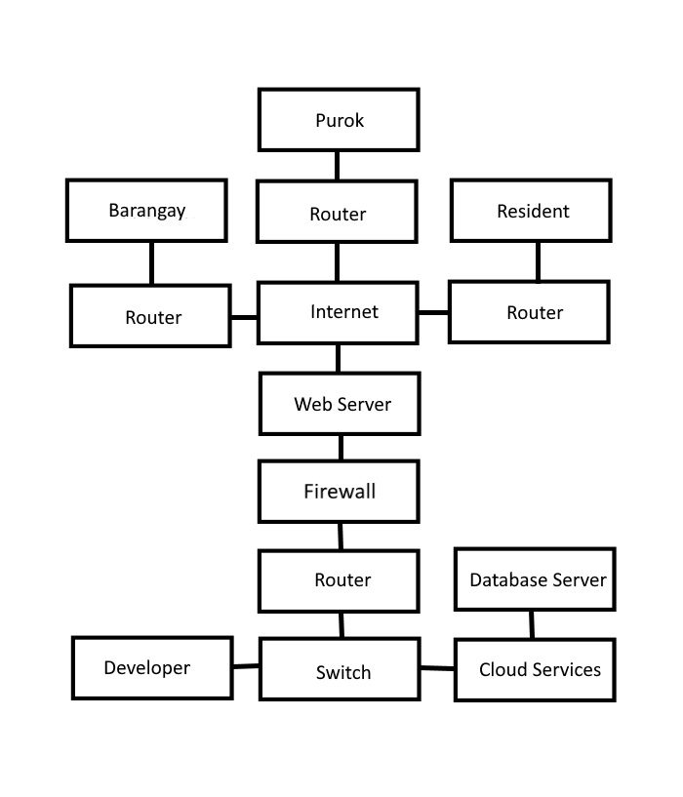

Figure 51: **Network Model**

eBarangay uses the TCP/IP as a framework for its network model. It serves as a peer-to-peer network connectivity for the developer, barangay, purok, and residents. It also uses Local Area Network (LAN) among computers and other devices that are connected within the same router.

**Network Topology**

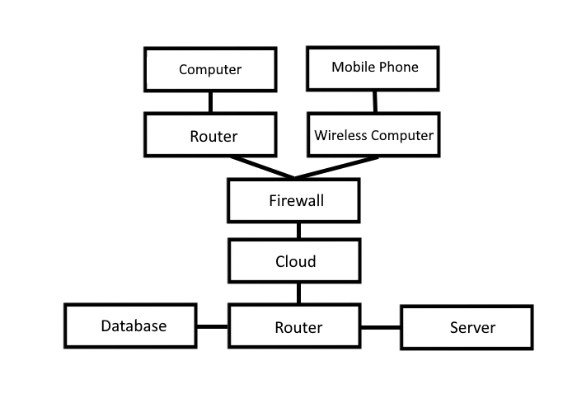 Network topology refers to the manner in which the links and nodes of a network are arranged to relate to each other. Topologies are categorized as either physical network topology, which is the physical signal transmission medium, or logical network topology, which refers to the manner in which data travels through the network between devices, independent of physical connection of the devices.

Figure 52: **Network Topology**

eBarangay uses a Star topology as its Network Topology. Users, such as the residents, purok leaders, and barangay officials can use can access the system online through desktop computers, and through their mobile devices such as laptops and mobile phones utilizing the accessibility of the internet.

**Development Phase**

**Technology Stack Diagram**

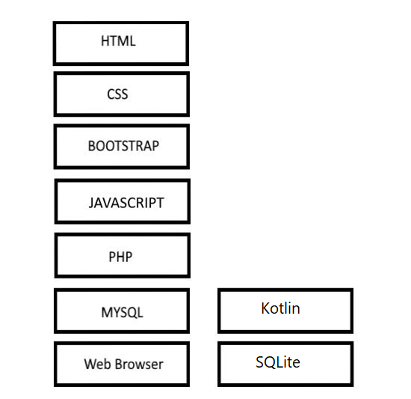

Figure 53: **Technology Stack Diagram**

The eBarangay will be developed with a sufficient amount of software. The software will be used in web developing for front end are Boostrap 4, CSS 3, Javascript, and HTML 5. The backend of the web system will be using PHP and MYSQL while Kotlin and SQLite for mobile.

**Software Specification**

SYSTEM SPECIFICATION DEVELOPMENT STAGE

Software Specification Development

Browser: Google Chrome, Mozilla Firefox, and/or Microsoft Edge

Operating System: Windows 7 or up

Internet Speed: 3 Mbps or higher

Application Tools: Visual Studio 2019

**Hardware Specification**

Hardware Specification refers to the requirement of the device hardware in order to perform functions.

|  |  |
| --- | --- |
| **Processor** | Intel® Core™ i5-4460 CPU @3.20GHz 3.20GHz |
| **Memory/RAM** | 8192mb or Higher |
| **Hard Disk Drive** | 500gb or Higher |
| **Monitor** | 15 inches 1366x768 60Hz |
| **Video Adapter** | Intel ® HD Graphics 3000 |
| **Keyboard** | Generic Keyboard |
| **Mouse** | Generic Mouse |
| **Ethernet Adapterx** | Realtek PCIe FE Family Controller |
| **Disk Drive** | DVD-R/W Driver |
| **USB Port** | 2.0 USB port or 3.0 USB port |

**Program Specification**

**List of Modules**

Table 7

Manage Account Module - Web

|  |  |  |  |  |  |  |  |
| --- | --- | --- | --- | --- | --- | --- | --- |
| Programmer | MODULES | RESIDENTS | PUROK | TREASURER | SECRETARY | CAPTAIN | ADMIN |
| Craige Jonard N. Baring  Rosvie R. Pepito | MANAGE ACCOUNT | | | | | | |
| CREATE ACCOUNT | * |  |  |  |  | * |
| VIEW ACCOUNT | * | * | * | * | * | * |
| UPDATE ACCOUNT | * | * | * | * | * | * |
| DEACTIVATE ACCOUNT |  |  |  |  |  | * |
| Number of Points  (1 Point per module per user) | | 1 | 1 | 1 | 1 | 1 | 1 |

Table 8

Request Document Module - Web

|  |  |  |  |  |  |  |  |
| --- | --- | --- | --- | --- | --- | --- | --- |
| Programmer | MODULES | RESIDENTS | PUROK | TREASURER | SECRETARY | CAPTAIN | ADMIN |
| Craige Jonard N. Baring  Rosvie R. Pepito | Request Document | | | | | | |
| CREATE REQUEST | * |  |  |  |  |  |
| VIEW REQUEST | * | * | * | * | * |  |
| CANCEL REQUEST | * |  |  |  |  |  |
| APPROVE/DISAPPROVE REQUEST |  | * | * | * |  |  |
| RECORD REQUEST |  | * | * | * |  |  |
| Number of Points  (1 Point per module per user) | | 1 | 1 | 1 | 1 | 1 | 0 |

Table 9

eBulletin Module - Web

|  |  |  |  |  |  |  |  |
| --- | --- | --- | --- | --- | --- | --- | --- |
| Programmer | MODULES | RESIDENTS | PUROK | TREASURER | SECRETARY | CAPTAIN | ADMIN |
| Craige Jonard N. Baring  Rosvie R. Pepito | eBulletin Module | | | | | | |
| VIEW POST | * | * | * | * | * |  |
| CREATE POST |  | * | * | * | * |  |
| UPDATE POST |  | * | * | * | * |  |
| DELETE POST |  | * | * | * | * |  |
| Number of Points  (1 Point per module per user) | | 1 | 1 | 1 | 1 | 1 | 0 |

Table 10

Manage Complaints Module - Web

|  |  |  |  |  |  |  |  |
| --- | --- | --- | --- | --- | --- | --- | --- |
| Programmer | MODULES | RESIDENTS | PUROK | TREASURER | SECRETARY | CAPTAIN | ADMIN |
| Craige Jonard N. Baring  Rosvie R. Pepito | MANAGE COMPLAINTS | | | | | | |
| CREATE COMPLAINT | * |  |  |  |  |  |
| VIEW COMPLAINT | * | * |  | * | * |  |
| CANCEL COMPLAINT | * |  |  |  |  |  |
| SEND COMPLAINT | * |  |  |  |  |  |
| RESOLVE / UNRESOLVE COMPLAINT |  | * |  | * | * |  |
|  | RECORD COMPLAINT |  | * |  | * | * |  |
| Number of Points  (1 Point per module per user) | | 1 | 1 | 0 | 1 | 1 | 0 |

Table 11

Manage Residents Module - Web

|  |  |  |  |  |  |  |  |
| --- | --- | --- | --- | --- | --- | --- | --- |
| Programmer | MODULES | RESIDENTS | PUROK | TREASURER | SECRETARY | CAPTAIN | ADMIN |
| Craige Jonard N. Baring  Rosvie R. Pepito | MANAGE RESIDENTS | | | | | | |
| VIEW RESIDENTS | * | * | * | * | * |  |
| ADD RESIDENTS |  | * |  |  | * |  |
| DEACTIVATE RESIDENTS |  | * |  |  | * |  |
| VERIFY RESIDENTS |  | * |  |  |  |  |
| Number of Points  (1 Point per module per user) | | 1 | 1 | 1 | 1 | 1 | 0 |

Table 12

Manage Notification/Massages Module - Web

|  |  |  |  |  |  |  |  |
| --- | --- | --- | --- | --- | --- | --- | --- |
| Programmer | MODULES | RESIDENTS | PUROK | TREASURER | SECRETARY | CAPTAIN | ADMIN |
| Craige Jonard N. Baring  Rosvie R. Pepito | MANAGE NOTIFICATION/MESSAGES | | | | | | |
| PUSH | * | * | * | * | * |  |
| SEND MESSAGE | * | * | * | * | * |  |
| Number of Points  (1 Point per module per user) | | 1 | 1 | 1 | 1 | 1 | 0 |

Table 13

Voting Module - Web

|  |  |  |  |  |  |  |  |
| --- | --- | --- | --- | --- | --- | --- | --- |
| Programmer | MODULES | RESIDENTS | PUROK | TREASURER | SECRETARY | CAPTAIN | ADMIN |
| Craige Jonard N. Baring  Rosvie R. Pepito | VOTING | | | | | | |
| ADD CANDIDATE |  |  |  |  | * |  |
| UPDATE CANDIDATE |  |  |  |  | * |  |
| REMOVE  CANDIDATE |  |  |  |  | * |  |
| VIEW  CANDIDATE | * | * | * | * | * |  |
| VOTE CANDIDATE | * | * | * | * |  |  |
| Number of Points  (1 Point per module per user) | | 1 | 1 | 1 | 1 | 1 | 0 |

Table 14

Manage Account Module - Mobile

|  |  |  |  |  |  |  |  |
| --- | --- | --- | --- | --- | --- | --- | --- |
| Programmer | MODULES | RESIDENTS | PUROK | TREASURER | SECRETARY | CAPTAIN | ADMIN |
| Sajid Cadavero | MANAGE ACCOUNT | | | | | | |
| CREATE ACCOUNT |  | * |  |  |  |  |
| VIEW ACCOUNT | * | * | * | * | * |  |
| UPDATE ACCOUNT | * | * | * | * | * |  |
| Number of Points  (1 Point per module per user) | | 1 | 1 | 1 | 1 | 1 | 0 |

Table 15

Request Document Module - Mobile

|  |  |  |  |  |  |  |  |
| --- | --- | --- | --- | --- | --- | --- | --- |
| Programmer | MODULES | RESIDENTS | PUROK | TREASURER | SECRETARY | CAPTAIN | ADMIN |
| Sajid Cadavero | Request Document | | | | | | |
| CREATE REQUEST | * |  |  |  |  |  |
| VIEW REQUEST | * | * | * | * | * |  |
| CANCEL REQUEST | * |  |  |  |  |  |
| Number of Points  (1 Point per module per user) | | 1 | 1 | 1 | 1 | 1 | 0 |

Table 16

eBulletin Module - Mobile

|  |  |  |  |  |  |  |  |
| --- | --- | --- | --- | --- | --- | --- | --- |
| Programmer | MODULES | RESIDENTS | PUROK | TREASURER | SECRETARY | CAPTAIN | ADMIN |
| Sajid Cadavero | eBulletin Module | | | | | | |
| VIEW POST | * | * | * | * | * |  |
| CREATE POST |  | * | * | * | * |  |
| UPDATE POST |  | * | * | * | * |  |
| DELETE POST |  | * | * | * | * |  |
| Number of Points  (1 Point per module per user) | | 1 | 1 | 1 | 1 | 1 | 0 |

Table 17

Manage Complaints Module - Mobile

|  |  |  |  |  |  |  |  |
| --- | --- | --- | --- | --- | --- | --- | --- |
| Programmer | MODULES | RESIDENTS | PUROK | TREASURER | SECRETARY | CAPTAIN | ADMIN |
| Sajid Cadavero | MANAGE COMPLAINTS | | | | | | |
| CREATE COMPLAINT | * |  |  |  |  |  |
| VIEW COMPLAINT | * | * |  | * | * |  |
| CANCEL COMPLAINT | * |  |  |  |  |  |
| SEND COMPLAINT | * |  |  |  |  |  |
| Number of Points  (1 Point per module per user) | | 1 | 1 | 0 | 1 | 1 | 0 |

**Testing Phase**

**Unit Testing**

The developers have tested each module and inputs required for its functions. The developers recommend using PHP unit as a tool for unit testing. It is a programmer-oriented testing framework for PHP. It is an instance of the unit architecture for unit testing frameworks.

**Integration Testing**

The developers tested each module and how they interact and communicate with each other. The purpose of this test is to check how each modules interact and expose any defects that might occur from performing certain actions in between modules once they are integrated.

**Implementation/Development Phase**

**Software Specification**

SYSTEM SPECIFICATION DEVELOPMENT STAGE

Software Specification Development

Browser: Google Chrome, Mozilla Firefox, and/or Microsoft Edge

Operating System: Windows 7 or up

Internet Speed: 3 Mbps or higher

Application Tools: Visual Studio 2019

**Hardware Specification**

Hardware Specification refers to the requirement of the device hardware in order to perform functions.

|  |  |
| --- | --- |
| **Processor** | Intel® Core™ i5-4460 CPU @3.20GHz 3.20GHz |
| **Memory/RAM** | 8192mb or Higher |
| **Hard Disk Drive** | 500gb or Higher |
| **Monitor** | 15 inches 1366x768 60Hz |
| **Video Adapter** | Intel ® HD Graphics 3000 |
| **Keyboard** | Generic Keyboard |
| **Mouse** | Generic Mouse |
| **Ethernet Adapterx** | Realtek PCIe FE Family Controller |
| **Disk Drive** | DVD-R/W Driver |
| **USB Port** | 2.0 USB port or 3.0 USB port |

**User-Guide**

1. Input the link to the browser
2. 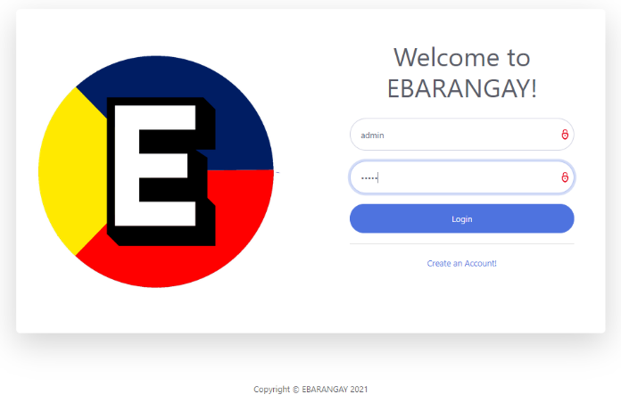Log in the default username and password is **admin.**

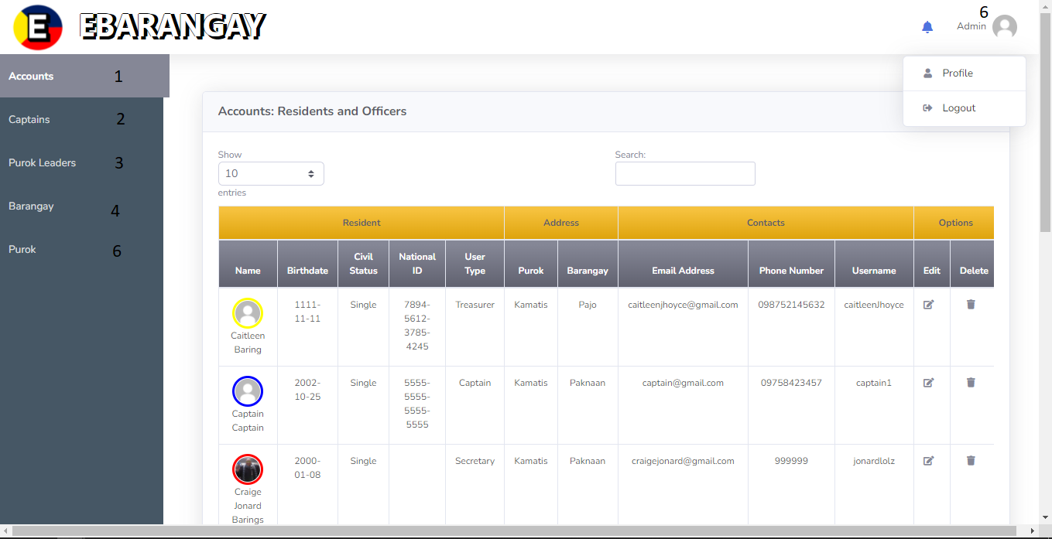Figure 54: **Login-User Guide**

Figure 55: **Admin Page – User Guide**

1. **Label 1** is where admin can see all accounts of the barangay captain, secretary, treasurer and purok leader. Admin can add, edit and deactivate an account.

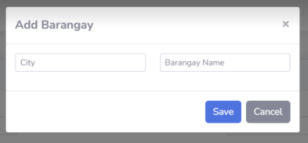



Figure 56: **Buttons – User Guide**  Figure 57: **Add Barangay/Purok Name– User Guide**

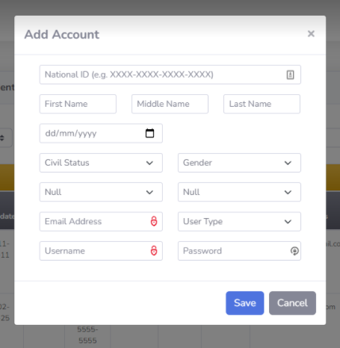

1. **Label 2** is where admin can see all accounts of the barangay captain within their barangay area. Admin can add, edit and deactivate an account.
2. **Label 3** is where admin can see all accounts of the purok leader within their purok and barangay area. Admin can add, edit and deactivate an account.

Figure 58: **Add Account – User Guide**

1. **Label 4** is where admin add a barangay name. Admin can also edit and deactivate a barangay name.
2. **Label 5** iswhere admin add a purok name. Admin can also edit and deactivate a purok name.
3. **Label 6** is where admin can logout or view profile.

For the captain, secretary, treasurer, purok leader and resident users.

1. 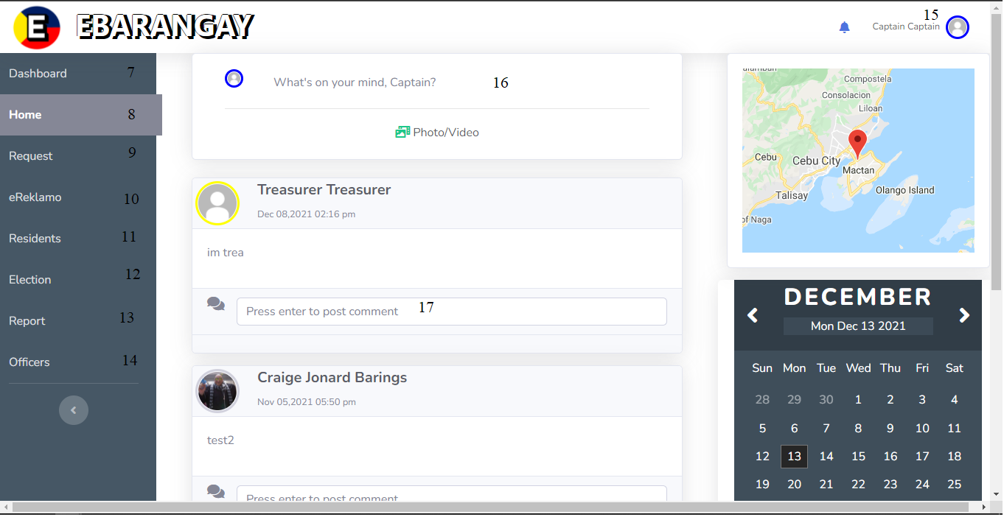Sign up the captain/secretary/treasurer/purok leader account and log in.

Figure 59: **Captain Page – User Guide**

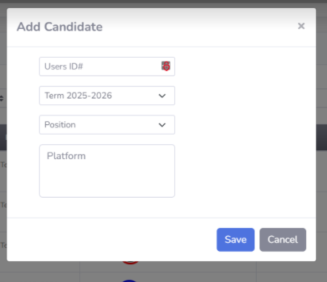

Figure 60: **Add Candidate – User Guide**

1. **Label 8** shows the home page of the captain/secretary/treasurer/purok leader page. This is where captain/secretary/treasurer/purok leader can post announcements in **Label 16 and** comment in **Label 17.**
2. **Label 7** is where the captain/secretary/treasurer/purok leader dashboard. It shows the number of pending documents and number of residents.
3. **Label 9** is where the list of requested documents of captain/secretary/treasurer/purok leader by users. While resident can request document.
4. **Label 10** is where the list of eReklamo of captain/secretary/treasurer/purok leader by users. While resident can send complaints.
5. **Label 11** is where the list of residents of the captain/secretary/treasurer/purok leader.
6. **Label 12** is where the captain held the election. Captain can add candidate to nominate. While secretary/treasurer/purok leader/resident can vote.
7. **Label 13** is where the reports of captain/secretary/treasurer/purok leader are located.
8. **Label 14** is where the list of officers all users is located.
9. **Label 15** is where captain/secretary/treasurer/purok leader/resident can logout or view profile.

**Mobile**

Login with the credentials given by the Purok.

 

Figure 61: **Login Page – User Guide** Figure 62: **eBulletin – User Guide**

The user logs in with their account credentials given to them by the purok.

The first thing they will encounter will be the eBulletin. The only people who can post to the eBulletin will be barangay officials, which are the purok, treasurer, secretary and the captain. Here they will receive information about all the events of the barangay down to the general information of the city.

 

Figure 63: **Navigation – User Guide** Figure 64: **Request – User Guide**

In the drawer menu, you will see a list of items that will direct you to different activities. There is the Request, eReklamo, Residents, Officials, Profiles and Logout button.

For the Request Activity, they will be able to ask for documents that are normally given to residents. They can request for available documents with their details.

 

Figure 65: **Complaint – User Guide** Figure 66: **Residents – User Guide**

Another activity is the eReklamo, it consists of the complaints you want to report to the barangay. Depending on the situation of the problem, it will be handled either by the purok first, or the higher ups of the barangay. If the problem can be handled easily, by conversation and negotiations, it won’t have to be redirected to the higher officials of the barangay.

Then there’s the Resident Activity. It shows all the residents of the barangay, if the officials are purok leaders, they will only have access to the information of the residents assigned to them. Higher officials have access to all the residents of the barangay. You can search and filter out the residents for you to have easy access to specific people.



Figure 67: **Profile – User Guide**

Lastly, is the Profile Activity. In this activity, it is simple, it shows the user’s information for them to see. They can use this if any barangay official wants to verify if the people in the barangay are residents or not.

**Installation Guide**

Web

With our system, the eBarangay, does not need to be installed since it will be published on a hosting service. If the user plans on using or testing the system using a local server then follow these steps:

1. First, the user will be required to install a software that mimics a local server. The researchers recommend the user to install and use XAMPP as it is easier and simpler to use, and it utilizes the power of the MySQL database.
2. After installing your XAMPP server, move the ebarangay folder to xampp/htdocs and simply open up XAMPP and click “Start” on both Apache and MySQL to start your local server.
3. On a browser, type in the URL: “localhost/phpmyadmin” and you’ll be redirected to your MySQL database.
4. Inside the MySQL database, click the “Import” button located at the top of the webpage.
5. Inside the webpage, click on “Choose File” and upload the ebarangaydb.sql file located in eBarangay > database.
6. After it finishes uploading, scroll down you’re the webpage and click on “Go” and this will import the database files the system uses.
7. Lastly, simply go to “localhost/ebarangaydb” and you’ll be redirected to the login page of our system. Enter the credentials admin for user, and admin for password.

Mobile

The mobile version of the eBarangay Management System is a way of the user to the opportunity to have easy to use device when they want to have an update to some of the information you want to know when viewing or scrolling that concerns you, the barangay or sometimes, the city itself.

With the mobile application, the actions that are available are limited. You can mostly view to gain information like events or updates.

This document is to guide the user of what the application is all about and how to install it successfully.

Pre-installation Requirements. The following prerequisites and requirements must be satisfied in order for the to install successfully.

Mobile Prerequisites. Phone must be smartphones. Technology and applications nowadays are reliant to smartphones because of the functions that are present that are only available to them.

Platform Version must be above Android 7.0. Again, there are only functions that are available to updated versions, making it easier for both the users and the developers when using or developing the application.

The API level is at least 24, version code is Nougat.

**Installing the application**

For the installation, you need to download the application first. The application will be available in APK file and possibly be available to Google Play Store.

After downloading, install the application and wait for it to be done installing. After installing, the application will be ready to use as soon as you enter your credentials that was given to you by your respective purok leaders. Then the application is now ready to use for your convenience, to scroll for updates of your concerns, your request of documents, or the updates of the barangay or the city.

**CONCLUSION**

To conclude the study, the aim of this study is to:

* + The system will help residents be able to disseminate their needs and concerns they have to their barangay easily with just a few clicks.
  + The system allows the residents to request documents more easily and hassle-free.
  + The system aids the barangay to communicate their announcements and information directly to their respective residents.
  + The system will allow the barangay to have an accessible list of their residents, down to which Purok they live in.

To reach the goal in implementing these features into the system, the researchers/developers needed to communicate and interview their local barangays on what they need and seek from a barangay system. From what the researchers have gathered, most barangays lack the tools and equipment to perform profiling on their residents, and some outright not having a list of their own residents.

With our first aim of the study, the researchers observed that the residents experience a difficulty in communicating their concerns to their barangay. Although suggestion/complaint box exist in the barangay halls, not everyone can take the time and travel to their local barangay just to submit a complaint that is unlikely to be even heard of, or even taken action.

For our second of the study, the researchers found out how unlikely some barangay residents intend to travel far just to submit a complaint, but with barangay documents where they’re required for employment and other important uses. Luckily, the barangay halls have a functioning system when it comes requesting a document in person, but we intend to help the residents who cannot make time to travel to their barangay hall, especially during the time of the pandemic.

With our third aim of the study, barangays have a hard time communicating their announcements and information to their very own residents. One option they have is to announce it via social media platforms like Facebook, which worked for them. Although, from observing the residents, there was only a low rate of people who knew their barangay has a group page, nor do they know how to navigate and find their own barangay group page. Our intention is to give barangays and residents a more convenient and faster way to send and see announcements.

For our fourth aim of the study, we intend to give the barangay who lack the list and details of their residents by providing a way for residents to easily submit their information directly to the barangay, having the less need to go door-to-door. The obstacle the researchers have found is the difficulty to identify which information submitted by the resident is authentic.

The results from our research have shown evidence on the importance of the eBarangay system to the community. The barangay and residents can greatly benefit from the system by providing a more healthy ecosystem of information between the barangay, purok and their residents.

**RECOMMENDATION**

The researchers’ recommendation to the future researchers is to find a system that helps the system detect which information submitted by their residents is authentic, or in the least, limit the submission of ‘trash data’ into the system. Second is to provide a payment option to the residents when they request a document from the app. Third is to question and interview your own local barangay and what tools they need to perform better as a barangay, as each barangay has their own different needs. This way, the ebarangay can slowly grow with additional features. Fourth is to have an better overall mobile and web Human Computer Interaction to lessen the confusion that users experience from using the system.

**REFERENCES**

Ramirez, N. (2017, May 16). San Fran’s purok system, a deterrent against criminals. CebuDailyNews. Retrieved from <https://bit.ly/3x5vlpa>

Matthies, A. (2017). “Community-Based Disaster Risk Management in the Philippines: Achievements and challenges of the Purok System.” Austrian Journal of South-East Asian Studies, 10(1), 101-108. Retrieved from <https://bit.ly/3qmtMkg>

Cheng, R. R. (2019). Building Community-based Resilience in the Municipality of San Francisco, Cebu, Philippines. GDI. Retrieved from <https://bit.ly/3vSHYmr>

Curato, N., Calamba, S. T. (2018). Surviving Disasters by Suppressing Political Storms: Participition as Knowledge Transfer in Community-Based Disaster Governance. Sage Journals. Retrieved from <https://bit.ly/2T0SDOn>

Ponce de Leon, I. Z. (2021). International Journal of Disaster Risk Reduction. ScienceDirect. Retrieved from <https://bit.ly/2TYSFGC>

Institutionalizing the purok system. (2017, October). CebuDailyNews. Retrieved from https://bit.ly/3gYoRSt

**APPENDICES**

**Appendix N. Capstone 2 Oath of Confirmation**

Date: October 6, 2021

**OATH OF CONFIRMATION**

             This is to confirm that I, Craige Jonard N. Baring, a BSIT-3 student, currently enrolled in the course of Capstone Project and Research 2, have aptly received a copy; religiously read and understood its contents; and openly submit to the terms, rules, conditions and regulations stated in the Capstone Project Manual document implemented by the Subject Teacher.

This is also to affirm that said guidelines were judiciously discussed and explicitly elaborated in a forum conducted by the Subject Teacher.



CONFORME:

Craige Jonard N. Baring

(Signature of Student over Printed name) / Date

Date: October 6, 2021

**OATH OF CONFIRMATION**

             This is to confirm that I, Craige Jonard N. Baring, a BSIT-3 student, currently enrolled in the course of Capstone Project and Research 2, have aptly received a copy; religiously read and understood its contents; and openly submit to the terms, rules, conditions and regulations stated in the Capstone Project Manual document implemented by the Subject Teacher.

This is also to affirm that said guidelines were judiciously discussed and explicitly elaborated in a forum conducted by the Subject Teacher.



CONFORME:

Criage Jonard N. Baring

(Signature of Student over Printed name)/ Date

Date: October 6, 2021

**OATH OF CONFIRMATION**

             This is to confirm that I, Rosvie R. Pepito, a BSIT-3 student, currently enrolled in the course of Capstone Project and Research 2, have aptly received a copy; religiously read and understood its contents; and openly submit to the terms, rules, conditions and regulations stated in the Capstone Project Manual document implemented by the Subject Teacher.

This is also to affirm that said guidelines were judiciously discussed and explicitly elaborated in a forum conducted by the Subject Teacher.



CONFORME:

Rosvie R. Pepito

(Signature of Student over Printed name) / Date

Date: October 6, 2021

**OATH OF CONFIRMATION**

             This is to confirm that I, Rosvie R. Pepito, a BSIT-3 student, currently enrolled in the course of Capstone Project and Research 2, have aptly received a copy; religiously read and understood its contents; and openly submit to the terms, rules, conditions and regulations stated in the Capstone Project Manual document implemented by the Subject Teacher.

This is also to affirm that said guidelines were judiciously discussed and explicitly elaborated in a forum conducted by the Subject Teacher.



CONFORME:

Rosvie R. Pepito

(Signature of Student over Printed name) / Date

Date: October 6, 2021

**OATH OF CONFIRMATION**

             This is to confirm that I, Sajid Cadavero, a BSIT-3 student, currently enrolled in the course of Capstone Project and Research 2, have aptly received a copy; religiously read and understood its contents; and openly submit to the terms, rules, conditions and regulations stated in the Capstone Project Manual document implemented by the Subject Teacher.

This is also to affirm that said guidelines were judiciously discussed and explicitly elaborated in a forum conducted by the Subject Teacher.



CONFORME:

Sajid Cadavero

(Signature of Student over Printed name) / Date

Date: October 6, 2021

**OATH OF CONFIRMATION**

             This is to confirm that I, Sajid Cadavero, a BSIT-3 student, currently enrolled in the course of Capstone Project and Research 2, have aptly received a copy; religiously read and understood its contents; and openly submit to the terms, rules, conditions and regulations stated in the Capstone Project Manual document implemented by the Subject Teacher.

This is also to affirm that said guidelines were judiciously discussed and explicitly elaborated in a forum conducted by the Subject Teacher.



CONFORME:

Sajid Cadavero

(Signature of Student over Printed name) / Date

**Appendix B. Research Working Title Form**

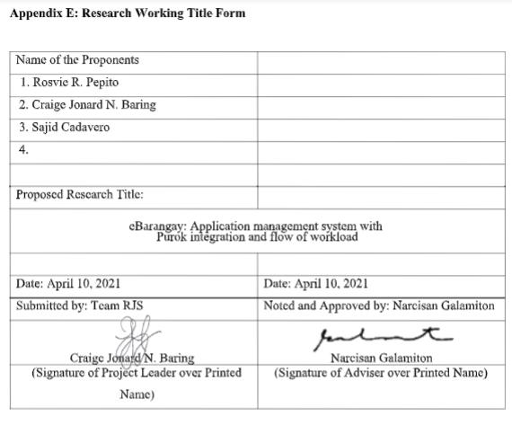

**Appendix O. Capstone 2 Consultation Logs Form**

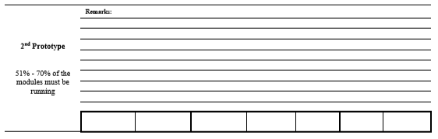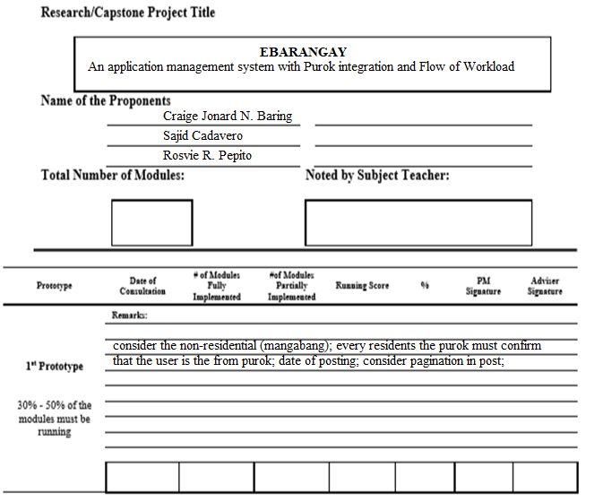

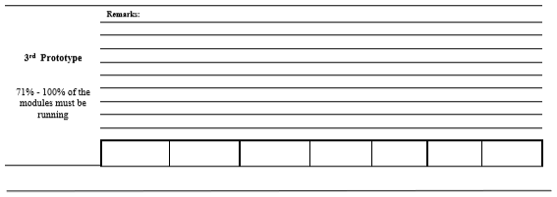

This is to certify that I have been regularly consulted by my advisees; have reviewed their system output as well as the required manuscript of the above-stated study. As their adviser, I, therefore, submit them ready for **Oral Defense** as their third prototype is within the required percentage.

__________________________________

(Signature of Adviser over printed name)

**CURRICULUM VITAE**

Name : CRAIGE JONARD N. BARING

Address : KAMANGGAHAN 1, PAJO,

LAPU-LAPU CITY, CEBU

E-Mail Address : craigejonard@gamil.com

**PERSONAL DATA**

Gender : MALE

Age : 21

Religion : ROMAN CATHOLIC

Civil Status : SINGLE

Citizenship : FILIPINO

Date of Birth : JANUARY 7, 2000

Place of Birth : LAPU-LAPU CITY

**EDUCATIONAL BACKGROUND**

SENIOR HIGH SCHOOL

School : UNIVERSITY OF CEBU - LAPU-LAPU AND MANDAUE

Address : A.C. CORTES AVE, MANDAUE CITY, 6014 CEBU

Year Graduated : 2017-2018

JUNIOR HIGH SCHOOL

School : UNIVERSITY OF CEBU - LAPU-LAPU AND MANDAUE

Address : A.C. CORTES AVE, MANDAUE CITY, 6014 CEBU

Year Graduated : 2015-2016

ELEMENTARY

School : UNIVERSITY OF CEBU - LAPU-LAPU AND MANDAUE

Address : A.C. CORTES AVE, MANDAUE CITY, 6014 CEBU

Year Graduated : 2011-2012

Name : SAJID O. CADAVERO

Address : M6 SITIO KAMANGGAHAN,

LABOGON, MANDAUE CITY, CEBU

E-Mail Address : sajidcadavero@gmail.com

**PERSONAL DATA**

Gender : MALE

Age : 21

Religion : ROMAN CATHOLIC

Civil Status : SINGLE

Citizenship : FILIPINO

Date of Birth : JUNE 28, 1999

Place of Birth : CEBU CITY

**EDUCATIONAL BACKGROUND**

SENIOR HIGH SCHOOL

School : ST. JOSEPH’S ACADEMY

Address : MANDAUE CITY, CEBU

Year Graduated : 2017-2018

JUNIOR HIGH SCHOOL

School : ST. JOSEPH’S ACADEMY

Address : MANDAUE CITY, CEBU

Year Graduated : 2015-2016

ELEMENTARY

School : ST. JOSEPH’S ACADEMY

Address : MANDAUE CITY, CEBU

Year Graduated : 2011-2012

Name : ROSVIE R. PEPITO

Address : ZONE SIBUYAS, PAKNAAN,

MANDAUE CITY, CEBU

E-Mail Address : pepitorosvie@gmail.com

**PERSONAL DATA**

Gender : FEMALE

Age : 21

Religion : ROMAN CATHOLIC

Civil Status : SINGLE

Citizenship : FILIPINO

Date of Birth : AUGUST 23, 1999

Place of Birth : BORBON, CEBU

**EDUCATIONAL BACKGROUND**

SENIOR HIGH SCHOOL

School : UNIVERSITY OF CEBU - LAPU-LAPU AND MANDAUE CAMPUS

Address : A.C. CORTES AVE, MANDAUE CITY, 6014 CEBU

Year Graduated : 2017-2018

JUNIOR HIGH SCHOOL

School : DON EMILIO OSMENA MEMORIAL HIGH SCHOOL

Address : SAGAY, BORBON, CEBU

Year Graduated : 2015-2016

ELEMENTARY

School : LAAW ELEMENTARY SCHOOL

Address : LAAW, BORBON, CEBU

Year Graduated : 2011-2012